|  |  |  |
| --- | --- | --- |
|  | **Sofia University “St. Kliment Ohridski”**  Faculty of Mathematics and Informatics  *Department “Software Technologies”* |  |

“Software Solution for Air Quality Visual Analytics”

**Master Thesis**

Diplomand: **Stefan Stefanov Baychev**

Major: **Software Technologies**

Faculty Number: **M24170**

Research Lead:

**Associate professor, PhD Dessislava Petrova-Antonova**

Sofia, 2019

**Contents**

1. Introduction 3

1.1. Big Data Air Quality Analysis Need and Motivation 3

1.2. Goals and Tasks to be completed by the thesis 4

1.3. Expected end result positives by the Thesis completion 6

1.4. Structure of the Master’s Thesis 6

2. Overview of the Air Quality Domain and Technical Specifications 8

2.1. Domain Basics 8

2.2. Ways and means to provide solution for the domain’s technical needs 9

2.3. Already existing and working solutions within the domain 10

2.4. Methodology and Analysis criteria decision making for the selected means of execution 17

2.5. Summary 21

3. Implementation Technologies Used and Other Know-How Methodologies 23

3.1. Criteria for methodology, domain knowledge means and software solution’s selection process 23

3.2. Comparison analysis of the variations of methodology, domain knowledge means and software solutions 25

3.3. The selection of methodology, domain knowledge means and software solutions 36

3.4. Summary 40

4. Analysis 41

4.1. Overall Model 41

4.2. Functional Requirements 42

4.3. Non-functional Requirements 43

4.4. Workflows 43

4.5. Summary 44

5. Design 46

5.1. Architecture of the Solution 46

5.2. Data Modelling 47

5.3. Information Flow 51

5.4. Means to Interact with the Solution 52

6. Solution Implementation and Use Cases Definition 56

6.1. Design execution of the Solution 56

6.2. System Integration - Packaging 61

6.3. Test Scenarios, procedures and planning 63

6.4. Analysis of the provided Functional Means 64

6.5. Deployment Mechanisms (technical needs, pre-conditions and usage) 72

7. Thesis Summary 73

7.1. Summary of the initially defined goals 73

7.2. Means and Ways for updates or/ and upgrades of the solution 75

List of Figures 76

List of Tables 78

List of Abbreviations 78

References 80

# Introduction

There are well known categories of life that are important for any person regardless of the place one lives or domain area of life he/ she is labouring as a day to day means to earn a living. Air quality and the known to the human body harmful effects of its detritions is one such aspect. Here is where Big Data, analysis of data and visualization alongside analytical means of its depiction in the domain of air quality come to the aid. Technologies are meant to serve a purpose and be applied on need to basis. In this case, it is the right place to put knowledge, need and the data into perspective. This chapter of the Master’s thesis would provide insight and knowledge into the subject matter of the domain knowledge, would go to touch upon what its expected end result is, lay out the information technology aspect and provide the descriptive structure for the overall thesis work.

## Big Data Air Quality Analysis Need and Motivation

The air quality in Sofia for the last 5 or so more years represents a serious problem due to the high frequency of occurrences that have undefined, yet detrimental to human health causes. One of the main factors defining air as human-healthy to breathe, is the quantity of coarse or ultrafine and soot particles (and other chemical compounds) within it **[****1****]**. As such, their controlled measurement and data collection means within well-defined norms all agreed upon EU member states **[****2****]**, is an important step on its own that can add to further the analytics within the realm of information sciences or know-how within the domain. These are some of the foundational elements and per say motivation for further gathering in more concrete means, re-categorization and providing means for visualization and analysis of such data types defining the air quality.

Current technologies for gathering, handling and visualization of Big Data **[****3****]** provide the means for analysis of non-granular, non-semantically or structurally same data sources that are to be displayed for analysis via interactive means with the end goal of well-founded and timely done decision making. The visual analysis/ analytics of data provides for the creation of graphical comparison depictions of trends and variations of dependencies, probabilities and others that make for the creation of data models. The data models on their end can be used for data point connections on a scale that raw statistical data means would not be sufficient.

At this point of time, there are a number of information data points gathering resources for air quality measurement. They are either government or private-social data points that provide a range of textual or/ and some visual web based software solutions. The data on display at those locations are not designed for analytical decision making or much of visual analytics or extraction, nor for relation definitions in a given time-frame, but for the broader audience of citizens’ informed awareness of it as such. The concrete name findings would be presented in the following chapters.

The visualization of such data and their respective data types handling of Big Data information pieces provides the analytical capabilities to deliver analysis of the air quality for a given time frame and possibly determining city areas with specific upper – negative or lower – positive quality values that can be further processed or subdivided and analytically displayed with their correlations.

## Goals and Tasks to be completed by the thesis

The goal of the thesis is design and development of a software solution for Visual Analytics of Air Quality by means of well-known and open source solutions (libraries, platforms and etc) for Big Data Ingestion, Transformation, Processing, Storage and Visualization.

There are a number of tasks that would need to be accomplished in order to achieve the desired goal:

* Overview of the domain area of air quality and the existing thus far mentioned solutions;
* Overview of the technologies that can be used and the ones are to be used for the solution development;
* Analysis of the requirements to achieve the software solution;
* Data Modelling and Design (data cleaning, data classification, storage and others);
* Design of the Software Solution;
* Development/ Engineering of the Software Solution;
* Validation and Analysis of results;

It would be good for information purposes to have the Technology Stack to be used listed:

Java 8, Docker, Apache Spark, Elastic Search, Kibana/ Grafana, Apache Maven, Git, IntelliJ Idea CE IDE

* **Apache Spark** – is a technology framework for distributed and scalable processing of big data information flows in memory. It is used for data ingestion and processing. It has Java API that provides for low-latency and upon successfully accomplished project defined processing criteria, the data is communicated with the Data Store, ElasticSearch.
* **Docker** - A container-based software solution that allows heterogeneous software applications to be configured to work and run regardless of the operating system. It is used within the master thesis software solution to provide a homogeneous operating environment for execution / access to Elastic Search and Kibana, with the future capability to provide for Spark cluster as well. Provides the deployment implementation of the first two software solutions mentioned, their distribution, portability and easy configuration access.
* **Elastic Search** - Non-relational database, Data Store, which uses its search engine to further process and analyze big data. In this case, the data sent by Spark is recorded in both the in-memory and the permanent memory storage locations. They are distributed and replicated according to pre-set settings. There is a very easy setting to be applied in the future for additional distributed big data access in a cluster.
* **Kibana/ Grafana** - It is used for visualization and visual analytical provisions in a subject matter area, in this case of air quality. The big data information flow is powered by an interface with Elastic Search. It has a wide range of visual analytical techniques based on statistical and other data analysis that are visualized through various types of graphical coordinate and geolocation / geographic maps and more.
* **Java 8 | Scala SDK** - A multi-target, object-oriented, high-level language. It is used to program the Spark defined program component, which indexes raw big data and subsequently further processes and communicates that data.
* **Scripting and Curl** - Network communications help tools for information flows that are defined by a set of command line patterns that are executed / interpreted by Curl or by other interpreters. In this case, part of the file script performs Curl commands communication tasks - defining Elastic Search as well as accessing and deploying of Docker specific usage for execution.
* **Apache Maven** - is a dependency definition/ resolution build bundling software solution. It is used to put together all dependencies and bundles the software solution’s core unit component. It is a mature, well developed and supported tool.
* **Git** – a distributed code base/ file version control system. Used as an incremental local development and remote changes tracking control. A Code base warehousing solution that is implemented on top of **Git**, called **GitHub** is used for the purposes of keeping the versioning and progress tracking long-term of the master thesis’s software solution.
* **InteliJ IDEA CE IDE** – is the community, open-source, free to use integrated development environment solution used for designing and development the software components of the master thesis. It offers a simple and practical way to create software applications with added ease of use and enhanced toolset for programming.

## Expected end result positives by the Thesis completion

As an end result from the to be provided insights into the Air Quality Domain Environment, currently existing solutions and the to be discussed Software Solution for Air Quality Visualization Analytics - this would be the backbone means for air quality data analytics based on predefined set of criteria. These criteria would have the option to be expandable, but under a given domain area of matching with the so far known. There would be portability to the software solution integrated within. What would be provided as tangible end result would include the solution, the know-how of why and how each step of the design and development was undertaken and a larger understanding the domain area and the means to provide visual analytics.

The given software solution would be developed with the idea to contribute to the Air Quality domain area of expertise and deliver insights into the means for decision making and above all display current ways for Big Data visual analytics.

## Structure of the Master’s Thesis

The Master Thesis is comprised of 8 chapters, each laying the foundations and thereupon delving deeper into the core aspects of the thesis.

Chapter 1, represents an Introduction to the topic of Air Quality, technologies and reasons for the undertaking of this work.

Chapter 2, represents an Overview of the Air Quality Domain Area, alongside technical insights into the domain specific needs. It includes analysis of existing solutions within the domain area and provisioning for the methodology and selection criteria for the development of the solution. At the end there would be a Review of the discussed within the chapter.

Chapter 3, represents an Analysis and selection criteria definition for the software solution’s specifics. These specifics relate to the domain area knowledge, method for analytics and technologies. It offers a discussion on the criteria for selection on each and also defines the reasons for considerations and selection. There would be a Review section briefing the discussion presented and some conclusion thoughts on the findings.

Chapter 4, represents an Analysis and walkthrough of the software solution’s main assumptions as model and expectations of workings. It describes how the functional and non-functional requirements are set as specific needs on the basis of supporting each other’s operational prerequisites.

Chapter 5, represents a deeper delve into the software solution. It shows the architecture and design of the programmed components and others such part of the overall solution. It would present the data modelling, the communication implementation patterns, as well as the information flow and interface means.

Chapter 6, represents an implementation detailed description, reasoning and analysis based on the information flow, domain needs and granular specifics on the given mechanisms applied.

Chapter 7, represents an overview conclusion on the different aspects of the domain needs, their implementation and end result. The general idea is to restate and conclude the foundational truths and definitions applied and how they relate to achieving the desired initially set end goals.

# Overview of the Air Quality Domain and Technical Specifications

The air quality domain is the broader subject matter of the health impeding chemical elements found in the air we breathe. It is also a world-wide initiative of gathering and sharing knowledge on the matter and agreeing upon measures of control to achieve health standards to be applied throughout all countries on the globe. The well documented chemical/ biological sources that cause harmful to the human body effects are being measured and recorded by various government and non-government institutions. The concrete sources are classified by severity of long term and immediate harmful effects and based on it they are being measured hourly, monthly and yearly per accumulation basis. **[****4****]**

What the domain needs is data, it’s gathering and correct classification. It also needs data analysis and visualization based on predefined criteria in order to have analytical decision making in support of trends or to analyse visually such. Big Data alongside the visualization aspects of it, give the tools needed for the domain’s main challenges.

Currently, there are a large number of solutions that provide some visualization and analytical aspects of the air quality data gathered either by them directly or through collaborative efforts. Yet, what is lacking is for one, the open sourcing of the technology, framework or overall solution used in a meaningful reusable way and the data itself. Another lacking aspect is the cumbersome row statistical data that the government based solutions provide and lastly but not least is the data gathering is not supported as a stream, nor are there any data storage points to extract or visualize information on predefined set of criteria.

Within the chapter sub-topics, there would be further details provided to the so far discussed and concrete insights.

## Domain Basics

Air Quality has been an ongoing topic in the day to day lives of all people regardless of their walk of life. Sofia, as a modern well industrialized city suffers greatly from harmful to the human health air quality conditions.

Air Quality is a domain that encompasses on one side the knowledge and know-how of what makes the air we breathe have good healthy quality or the opposite. On the other side are the means that this data is collected, measured and stored in some manner or form.

The air quality we breathe is measured using an index **[****1****]** that is comprised of several elements within it. The prominent ones, but not the only ones are as follows - particulate matter (PM 2.5 and PM 10), ground-level ozone (O3), nitrogen dioxide (NO2) and sulphur dioxide (SO2). **[****5****]**. Each one of the listed and a few more are main causing factors for detrimental to human health factors and at list in brief they need to be touched upon. The PM 2.5 and PM 10 represent in microns fine particulate matter and coarse particulate matter. They are the causation factors for respiratory and cardiovascular diseases. Their occurrence can be from many sources, but above all directly or indirectly from vehicles and other transportation means proponent, as well as heat energy generating sources, windblown soil, sand and similar. The O3, ground level ozone, in essence comes from chemical components reactions with sunlight. Its sources can be tracked to the so far mentioned as secondary effects of their occurrence or/ and in combination. The NO2, nitrogen dioxide, are the by-products of internal combustion activities related to vehicles and other forms of energy transfer or generation based on such forms of heat expansion.

The SO2, sulphur dioxide, is a well-known chemical compound that originates either from human caused activities of fossil fuel burning in the form of power generation, vehicle propellant, household generated from burning to create heat, or nature generated upon given geological activities of earth-tectonic activities and similar.

All of the above described air pollutants are being measured by either government owned air-quality checking stations spread out by city district areas or by non-profit private entities owned measurement apparatuses. It needs to be highlighted that the pollutant concentrations are measured in hours per given quantity found in the air and also per accumulation for a given time frame.

## Ways and means to provide solution for the domain’s technical needs

Air Quality as thus far discussed has a lot of data value properties by quantity that are also varied in terms of quality per specific needs. To distinguish and provide classification of this data, it’s first needed domain knowledge and there upon comes the technical needs as a result. Those needs relate to several factors, to name a few, data extraction/ gathering, data cleaning, data re-categorization/ exploration and (intermediary/ permanent) storage for specific needs, data modelling/ validation and lastly the visualization/ presentation of the data. The last step can come only if the data has been correctly handled. The technology to achieve all this comes under an umbrella name for a stack of such solutions called Big Data **[****3****]**. The term itself and related technological initiatives would be further discussed within the thesis, but for now the focus is to introduce it in short. It provides the backbone for the data handling via various software solutions and frameworks that work in collaboration or as separate entities. Big Data on its own provides the essentials for the additional part needed in Air Quality Visual Analytics, the visualization and then upon or by first data handling the analytical component. The visualization and analytics aspect is also comprised of software solutions that either work together with the big data components directly or they do so on their own.

## Already existing and working solutions within the domain

Within the Air Quality Domain’s technical side of data handling and visualization, exist a number of solutions that provide some usability on their own or based on already well defined software solutions. They are initiatives in the public and private realms of the topic at hand. Each provides some visualization solution to the data and even some analytical capabilities. Yet, each one has certain limitations based on the technology used, the representation of the data, ability to be analysed or overall usefulness - as multi-reference points of know-how and data. They all share a common factor of air quality domain data gathering and distributing it to the public. In the following lines, there would be an analysis of the workings and capabilities of the relatively well-known and in operation solutions.

1. **Airtube** and its concrete version for Bulgaria **AirBg** **[****6****]** are non-government, privately funded and managed initiatives for air quality measurement and data distribution with some visualization based on several criteria. The project originates from a German based non-government initiative that has provided the know-how and some of the hardware-software components for the measuring devices and in part for the visualization. There are off-branches in quite a few other European cities, others except Sofia in Bulgaria like Plovdiv, Varna and Burgas, as well as some world-wide ones across several continents.

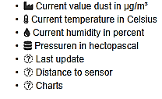

[**Figure 1: AirTube Display Criteria**]

The criteria are quite simple and as follows, as shown on **Figure 1**, dust particles in micrograms per cubic meter, the temperature in Celsius, humidity in percentages and air pressure in hectopascals.

They are very basic, as just mentioned, because the measurement apparatus used are not sophisticated or complex as the ones owned and managed by government and other weather-geo specific agencies. The apparatuses are IOT based devices that serve a single purpose, relatively cheap to purchase, assemble, power and place at locations. However, they still manage to provide good and more broader geographically data set on several leading indicators like PM, temperature, humidity and air pressure, all useful for further more in depth analysis and action plan to be undertaken by the domain experts.

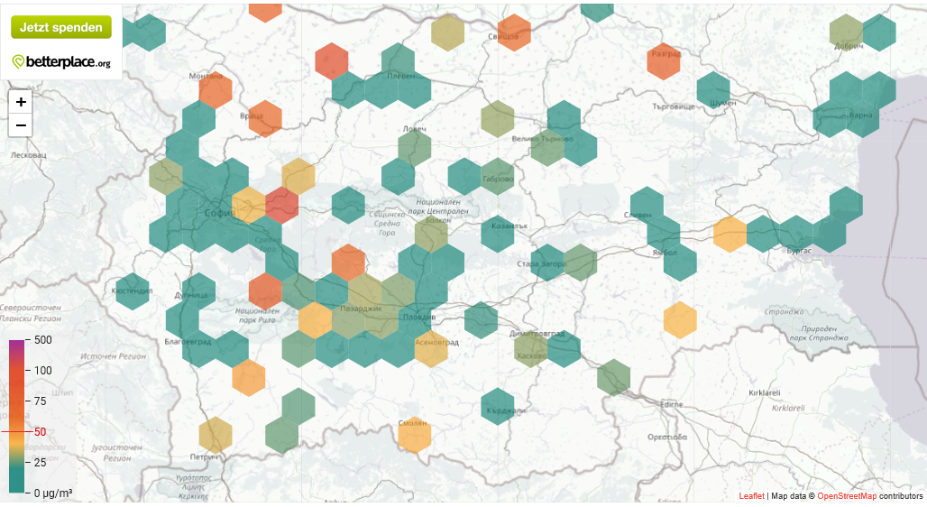

[**Figure 2: AirTube Bulgaria Stations**]

The sensor stations’ prevalence, as shown on **Figure 2**, is visible by hexagonal structures on the map above. Each one represents either a single or multiple in the vicinity such measuring stations. The different coloured hexagons from green veering to red, as visible to the left side bar scale, represent each station(s) health level indicator based on PM saturation of below or above 50 micrograms per cubic meter of air.

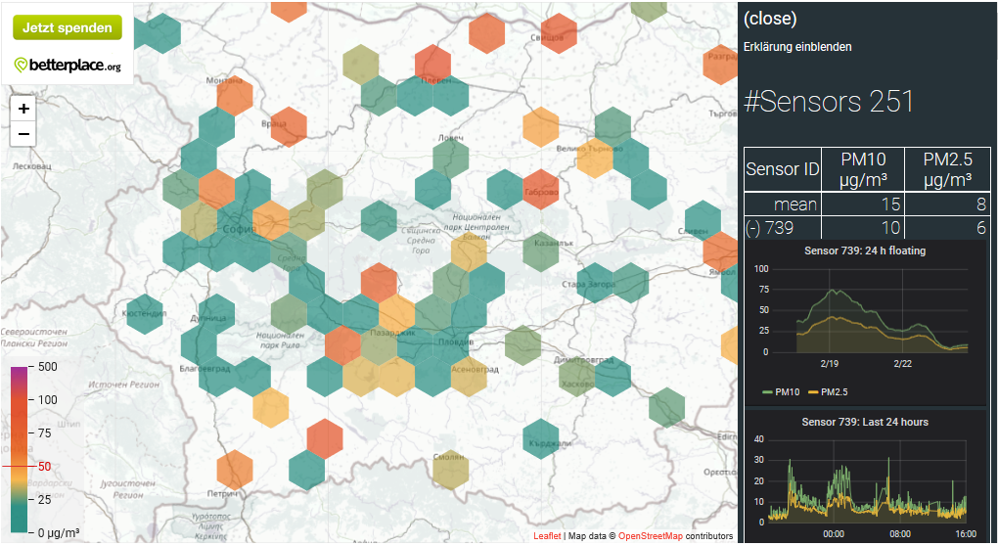

[**Figure 3: AirTube Bulgaria Sensor Data Display**]

Upon zooming, as shown on **Figure 3**, with the given plus or minus or via a mouse, one can navigate to a hexagon, select it and see the Sensor count and then upon pick a given sensor (as displayed above) and track the PM 10 and PM 2.5 mean variance for the last 24h of it and of the overall sensors’ statistics.

As the project’s main contributors and caretakers say, their aim is to be in support of the official government measurement efforts and tracking air quality workings. **[****6****]** Above all is the promising goal of “Open Data”, where all the data generated from dust measurement is open accessible for all. And indeed some of the data for the Bulgarian air quality measurement stations can be gathered from here - <https://data.airtube.info/>

The data accessible via this project is as is, based on them few measurement components. It is well formatted and has specific header columns that allow for ease of ingestion and further transformation within a Big Data tool. Yet, one drawback is the need to differentiate based on the geohashing function used for the sensor’s location. There is also no other differentiating factor for the sensor’s data gathered, it is per say hourly based from all data emitting sources.

Overall this solution gives a good provisioning for information sharing to be re-used by 3rd party solutions/ users via its Open Data initiative. Yet its own visual analytics capabilities are limited, as it allows only current date-time data view of the overall sensors’ coverage and per sensor overview is limited to only 24 hours’ time-frame.

1. The **European Environment Agency** provides, as shown on **Figures 4 to 6**, some visual and some textual data information points that give out for all EU countries air quality measurement statistics.

The provided Air Quality visualization services are rudimentary **[****7****]**. Regardless of the listed on them capabilities, they do not reflect any useful representation of data.

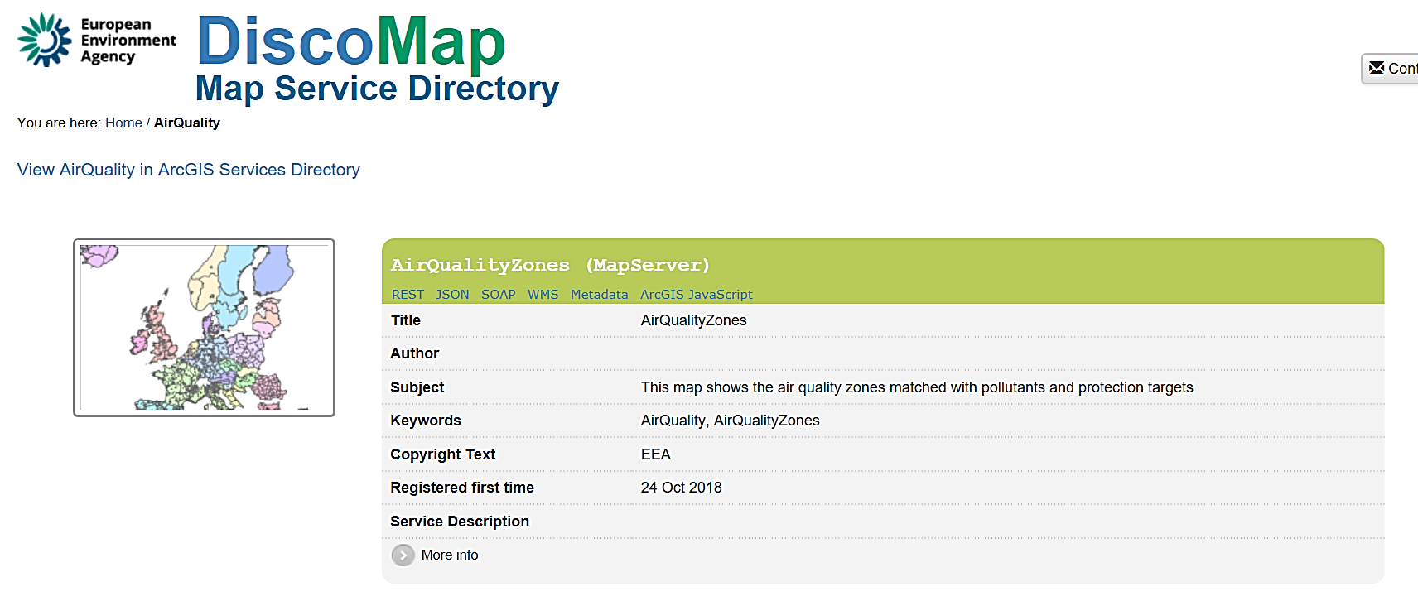

**[****Figure 4: EEA Agency Air Quality Zones****]**

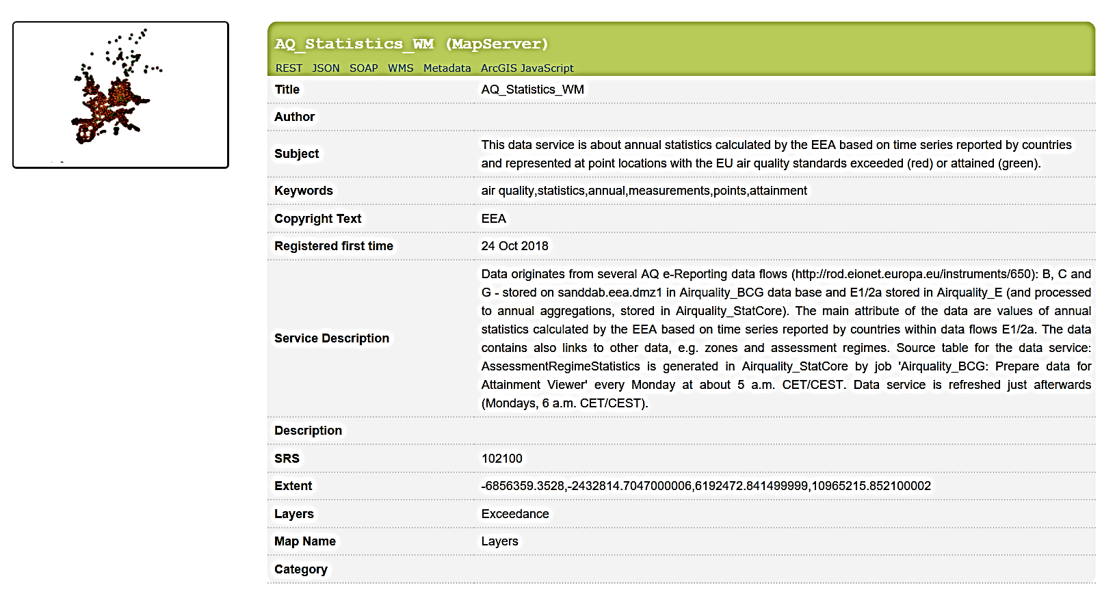

**[****Figure 5: EEA Agency Air Quality Statistics****]**

They can be used more for reference purpose rather than actual analysis or any other means of overall or specific air-quality related usefulness. Build on top of GIS with some static visualization content that does not adjust with any selected criteria for whatsoever visual analytics of the data.

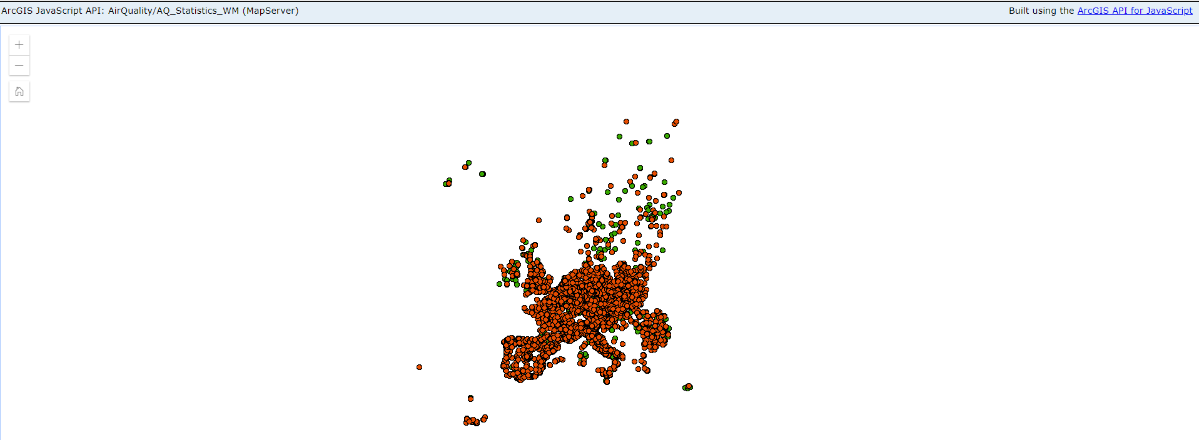

**[****Figure 6: EEA Agency Air Quality GIS****]**

There is data that each EU country submits to the European Environment Agency on given time intervals throughout the year. There is data for all EU countries and in specific Sofia, Bulgaria **[****8****]**. However, upon downloading, inspecting the data and performing data quality analysis, it is not information data quality adequate. It is not well formatted at all and is non-specific in its nature. It has on a single line comma separated the data for just a single pollutant, measured per day, with per say header that denotes what each comma separated value is. The non-specific means that albeit there is information on the station per some textual designation, it is unknown where and why only one station has this information recorded and provided from. The extracted data would need good amount of additional work for cleansing and rule definitions for the needed pieces to be visualized. It also is not up to date, as 2018 data is missing. **[****9****]**

1. **Bulgarian Government Environment Agency** **-** [**http://eea.government.bg/airq/**](http://eea.government.bg/airq/)

The Environment Agency is responsible for measuring the air quality by sampling and respective other means via its network of country-wide regional and city based stations. It is publishing a daily information piece of all stations/ city/ region that have surpassed the well-defined and above paragraphs discussed criteria for above the limit hazardous pollutants. This information piece reflects only the given locations and just for the day. There is no provisioning for other pollutants values to be seen, even for the listed stations unless they are in the category found in question. The measurement used is based on the reference values for the last 24 hours, visibly cited within the pollutant category, multiplied as a value in display, as shown on

**Figure 7**.

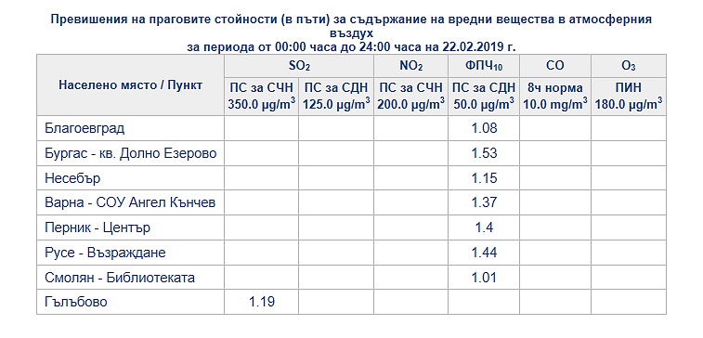**[****Figure 7: Bulgarian Environment Agency, Daily Chart of above Limit Pollutants per Station****]**

There are times when for technical or other reasons some of the data fields for the pollutants would be empty, as described within the agency’s web site. They also provide textual information that gives some suggestive or well documented sources for the pollutants abnormally high values measured.

There is archive information piece data following the same visualization methodology, for a backdating period of time. It provides as well only the option for a given day to have the data displayed. **[****10****]**

It is also good to note that the data from all national and regional stations gets pooled into respective centres, there upon analysed for quality and correctness and further upon every three months this data gets published within a Government made Memorandum for the Environment – this data piece is not provided as accessible by any open-source digital means. It is a well-documented analysis as visible per example for year 2016 **[****11****]**, but the data for the making of this broad and encompassing analysis is not open-sourced or documented to be accessible in such. 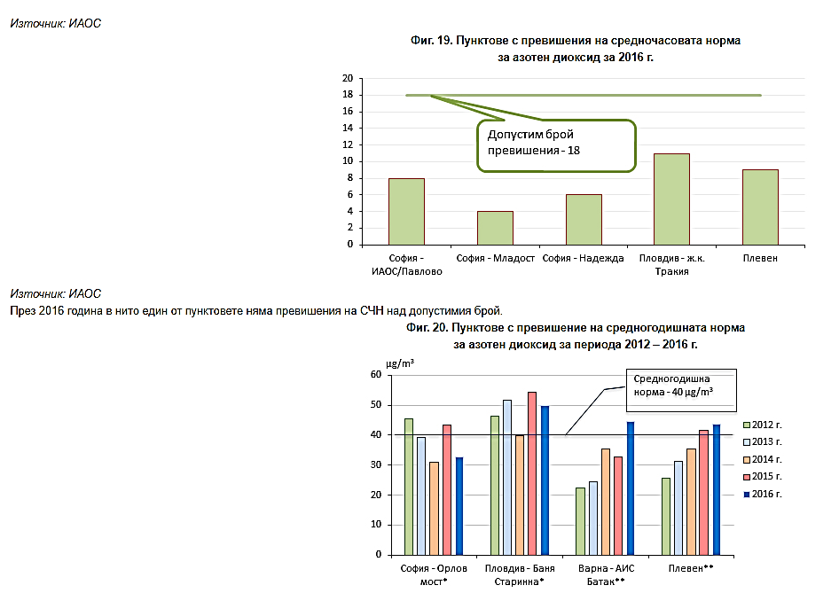**[****Figure 8: Bulgarian Environment Agency, Yearly Charts for NO2****]**

It is visible, as shown on **Figure 8** that there can be some analytics performed on the data provided as such, but it serves only the end negative spectrums of the variance and there is no information for the yearly trend or neither other simple statistics. The provided information is as is for only mean average threshold norms either per city/ station for the whole year or per some selected time frame. The data visualized in this way serves its purposes for the Agency’s work, but is not accessible for 3rd party users, nor can used or back-date accessed for any further analysis or analytics.

Overall the provided solution for air quality measurement is good enough, if one wants to track last day’s pollutants abnormal levels tracked and the place they were recorded at as a magnitude. There is no concrete information on the time of day of the occurrence, nor variance, nor other statistical information, but the deviation in magnitude according to the well established by the Bulgarian and EU authority’s norms.

The solution is rudimentary in its data display as pure statistics in table to some graph format. It does not provide any means for data extraction or other data manipulation for further analytical or/ and visualization purposes, but the displayed ones. It serves well its creators, but the overall usefulness is limited to indicate past date pollutant hazardous norms.

## Methodology and Analysis criteria decision making for the selected means of execution

Thus far, the foundational domain knowledge and some technical perspectives have been laid out. In order to proceed further and beforehand going any deeper into the technology architecture and implementation, the decision making criteria for execution as well as the standards to be followed would need to be defined.

The domain knowledge criteria decision making has already been established and discussed in some detail. It is good to mention that the same main data components would be used for the solution’s execution in this respect as available - meaning the PM and other well-known chemical compounds found in the air per given time frame and concentration. These data pieces and the well-established EU and Bulgaria’s Environment Agency definition for each would be the leading indicators for classification and visualization for analytical purposes. They would reference as follows within **Table 1**:

|  |  |  |  |
| --- | --- | --- | --- |
| **Pollutant** | **Average Yearly Value** | **Average Daily Norm** | **Average Hourly Norm** |
| **PM 2.5** | 25 micrograms per cubic meter | - | - |
| **PM 10** | 40 micrograms per cubic meter | 50 micrograms per cubic meter (can be exceeded 35 times per year) | - |
| **SO2** | - | 125 micrograms per cubic meter (can be exceeded 3 times per year) | 350 micrograms per cubic meter Norm (can be exceeded 24 times per year) |

**[****Table 1: Bulgarian Environment Agency, Pollutants Values and Norms** **[****12****]]**

The not so in depth or length covered decision making criteria for execution means comes from the Big Data Analytics domain and covers the aspects of data handling for such and in general most software solutions in the sphere with their domain specifics. There are five well defined steps in the Big Data Analytics process that have to be performed to achieve analytical capabilities of the data at hand. They are as follows, Data Gathering, Data Ingestion, Data Manipulation/ Processing, Data Persistence and Data Visualization. Each of them is part of the methodology behind the Data Analytics field and is integral as input product for one another. The better and well defined/ executed, the more meaning/ analytics and accuracy from the data would be successfully derived from. **[****13****]**

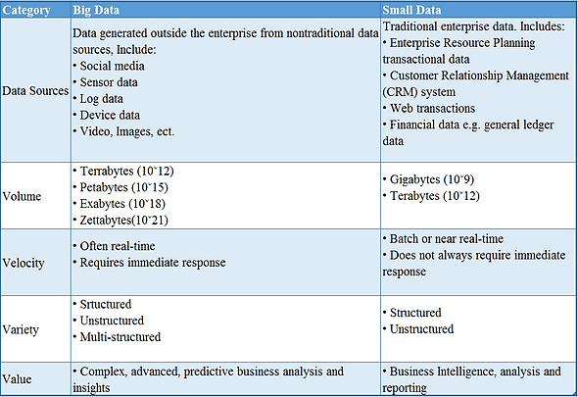

**[****Table 2: Big Data Definition per Category****]**

In continuation to the so far discussed and given the **Table 2** data above, it is clear that the Air Quality Visual Analytics solution would need to base itself using the nature of its information sourcing and also the already well-known covered aspects of its Volume, Velocity, Variety and Value. It must be kept in mind that this is not a checkbox mechanism for classification, but a guideline for good measurement of the big data analytical paradigm.

A walk through and detailed overview of the above mentioned data steps:

1. Data Gathering is the first criterion that needs to be established. Where are we to get our data from, what would be its document format and would it contain sufficient analytical capabilities to use upon down the line.
2. Data Ingestion is the second item to be considered. We should know the data format by now and be able to define the input criteria for handling. The ingestion process is also defined on how the data is to be consumed, if via batch processing or stream - dependent on the means the data can be gathered. There is a different software solution approach depending on the selected path as it leads to certain technological decision making and implementations.

An example would be, as shown on **Figure 9**, for stream based solution where there needs to be considerations first for the amount of data to be streamed/ consumed, how often would it happen, would it be direct service or via intermediary and what would happen if one of the parties is not able to send/ receive. These are key consideration points that on their own should be analysed further with respect to quality criteria to be found within, but cannot be given merit unless a specific non-technical specifications are to be evaluated as well. One of the main advantages of streamed data is accessibility-handling-visual analytics on demand that would provide decision making on a time-frame conscious basis for execution. A disadvantage that comes out very clear from the questions raised above, is data availability in case of network or/ and client/ consumer failure to handle the data before/ after/ during data operations. There are also other technical provisions that need to be handled in order to satisfy data latency transmission/ consumption and in essence software architecture deployment. **[****14****]**

Batch data ingestion, as shown on **Figure 9**, on the other hand, provides for in full data ingestion with no latency concerns, but depending on non-technical specifications (time frame for data ingestion process to be completed). A disadvantage to consider is the all or nothing approach when it comes to the ingestion process. If the ingestion data process for some reason gets to be interrupted/ stopped/ fails, there is a generally accepted rule that the ingestion is to be rolled back and all manipulations done on the data further down the line reverted. The consensus comes that it is a good practice to do so, as to guarantee data wholeness and uniformity and not having to handle complications of unknown or undefined characteristics, not to mention data accuracy pollution.

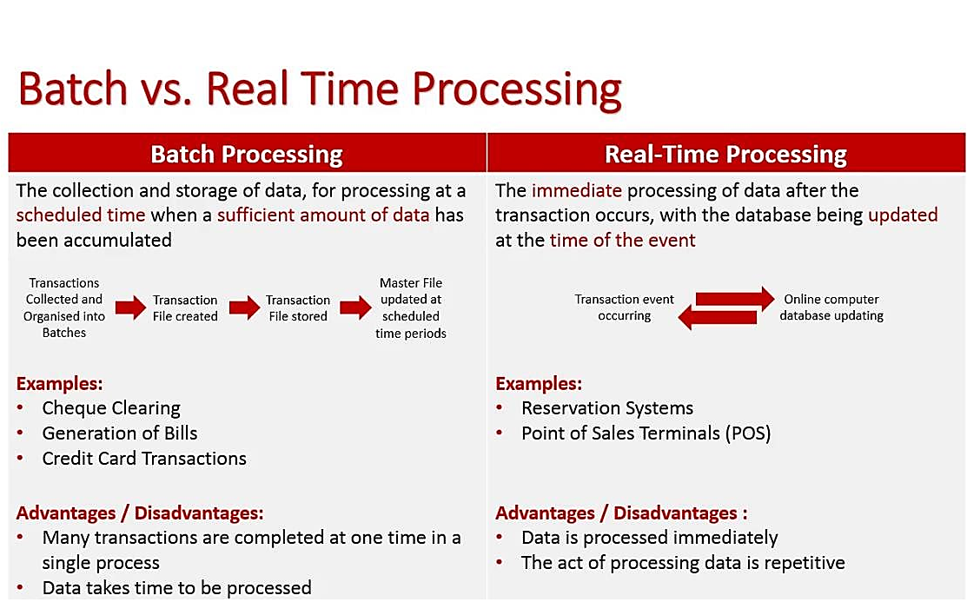

**[****Figure 9: Batch vs Real Time Data Processing Comparison****]**

1. Data Manipulation/ Processing as the name suggests, handles any instances where the in the process of or already ingested data is in need for some modifications. These modifications relate to data pruning, data type or format modifications and in some cases enrichment. The modifications are required for data correctness purposes that are established by a homogeneous data model based on the domain specifics and analytics ‘needs. **[****15****]**
2. Data Persistence is the straightforward step of storing the already gathered-ingested-manipulated data in some manner or form. Often enough, the means to execute this step would be dependent on our end goals for the data either in tandem with the visualization aspect and analytics or with idea in mind of future usability for either. The persistence is to be handled in some distributed manner using well established methodology patterns and technologies. It is worth to note that the current solution’s data is a semi-structured one. It has meaning only within domain context as part of a whole analysis, and thus the approach to be used is a NoSQL persistence solution. Given the nature of NoSQL to handle data on record/ document basis, it is in line with how each data piece is being generated as unit of information insight. Using the NoSQL information handling technology for persistence, it would provide for future possible extensibility of the persistence layer. It would be accomplished via technology mechanisms that allow for pooling of semantically similar data pieces and further performing manipulations and persistence executions. As just discussed, the manipulation and persistence methodology execution points are not necessarily following each other in the same manner all the time. Depending on the given solution’s current needs or future modification needs, these two steps can be interchanged and augmented to serve the analytical needs. **[****15****]**
3. The last step is Data Visualization as end means of the Big Data Analytics. What this step does is provisioning for the display and visual-analytical capabilities. It is done in respect to the domain’s needs of the so far handled data. The analytics part to a good degree is performed at this step, because the decision making is based on the backbone of the already performed data processing actions. This methodology step is to assist a broader decision making on the predefined criteria for the afore gathered data. Data Visualization aids the analytical end-means via provisioning of display information pieces that identify a certain data pattern or/ and allow for different viewpoints of data slices in time. **[****16****]**

## Summary

In this chapter, the main points covered related to the domain knowledge aspect of the thesis’ work, the know-how and needs of the domain data and technology information flows, as well as extensive summary of existing air quality analytics solutions.

All of the above discussed provided first a broader and more defined viewpoint of the domain specifics. Thus, it would enable an understanding of the terminology, the domain’s needs and build up sufficient knowledge to discern the complexities of the software (and hardware) solution(s) needed to furnish an accommodating visual analytical capabilities. Thereafter, with the definitions for the various existing domain solutions, the knowledge gathered allows for quality definition points depending on the provided accomplished implementations in respect to the aspects that an air quality visual analytics should consider to provide. The methodology and criteria selection discussion gave the means and understanding for the information flow that an actual solution needs to consider and attain to apply for in its design and execution phases.

In conclusion, thus far with the covered foundational domain knowledge, existing solution’s analysis and methodology of the decision making for the domain’s information flow, there is sufficient core topic fundamentals provided and expanded upon. It would allow for understanding of the upcoming technical solution discussions and overall need for certain domain understandings in order to achieve big data air quality visualization analytics.

# Implementation Technologies Used and Other Know-How Methodologies

In the broader spectrum of Big Data and Big Data Visualization/ Visual Analytics, there are a number of well-known technologies that can achieve the desired end goal result. However, in consideration of the main objective to have an applied and ease of reusability use-case for the software solution, there are certain criteria and decision makings that have influenced the technology choice. Other influencing factors are the data and format availability alongside the considerations for open-source, well established and complementing technology solutions, all in line with the domain area specifics.

The implementation technologies need to support sufficient data analytics capabilities and be extensible for future reuse directly or as a foundational building block.

It has been in part covered that there are certain methodologies in relation to Big Data Analytics that need to be used in order to have the data analysis aspect fulfilled. These methodologies relate to the data gathering and representation in mathematical statistics terms in relation to the domain area needs of air quality visual analytics.

The software implementation and methodologies used, have to be provided within the greater scope of the domain area in question. The domain area is the main proponent for the software solution and is the guiding mechanism that the technology needs to adhere to.   
 This chapter would further explore and give details on how all these technology considerations have been addressed. First, in the decision making, then the domain area specifics and know-how of the methodologies used for data analytics - via the software implementations provided.

## Criteria for methodology, domain knowledge means and software solution’s selection process

A baseline has to be established for criteria definition to be used in the three aspects of consideration that to a good degree form the creation of a domain specific Big Data Visual Analytics software solution.

All of the to be discussed criteria selection points would be further and in concrete terms described upon following the chapter’s narrative as a gradual introduction that aims to give a broader overview of the overall and then leading to the actual provided means.

First would be the methodology analysis as it slightly precedes the domain knowledge needs in terms of the perspective of analytics. To be more precise, what is in need to be established is the ways that the data is to be analysed. What would be the defining and needed criteria. The indicative aspect here is the branch of mathematical studies, statistics. Via well-known and also to be discussed software solution supported statistical methods for data representation, the data to be handled would be aggregated upon for analysis. This measure is needed as it would provide value added meaning to our large in quantity data, but low on quantitative meaning cohesive whole. Overall, this is the goal of Big Data and the Visual Analytics part, to facilitate meaningful data representation within a given domain area.  
 Second is the domain area knowledge means that have thus far been discussed, but not as a part of the overall criteria baseline needs. Air Quality has a number of already covered health detrimental defining characteristics, but several aspects define to a great degree its quality baseline. These are the characteristics of PM 2.5, PM 10, temperature, humidity and other chemical compounds found in the air. All of them have certain well known threshold values for given periods of time that are to be taken into account within the aforementioned methodology analysis. Having the domain knowledge means already extracted from scientific sources and discussed at length, provides us the framework to base them two criteria means as the pillars upon which the software solution needs to abide by in its design and execution means.

Correlating the domain area knowledge with the statistical analysis of the gathered data results in the formation of quality criteria. It represents the fusion for either currently doing a visually aided decision making or other future analytical works. It can also depict any lapses in the processes and means of the beforehand performed data handling steps. The result of the thus far discussed would be a determining factor that has to be taken into account. It could enrich currently or in future terms this one or similar Visual Analytical work. Well documented and reasoned decision making is the core of all Analytics work, as it provides way points and insights to base upon problem solving computational or other meta-physical related tasks.

We now have established the two quality criteria that needed to be taken into account in order to decide upon what software means should be considered. In essence, the software solution is to a good degree lays upon the domain needs and methodology analysis. The baseline would be to support Big Data Management and Analysis, as well as Visual Analytical capabilities via mathematical statistics based models. There is no need for overly complex solution at the time being, but one supporting sufficient capabilities to accomplish the first and second points of the discussed quality selection process. Still, it needs to be sufficiently robust to provide for further and more complex Visual Analytical capabilities, once the needs and criteria for it have been stated - in a similar fashion as currently being documented.

It has to be brought to attention that often enough, all these processes are not a straightforward approach of using the selected methodology, domain area means and the software solution. It is a multi-stage series of back and forth refining and pinpointing the right/ experienced or already well known ways to the overall Visual Analytical needs. Visual Analytics in the aspect of Big Data does need them criteria known beforehand, in order to hasten and correctly apply the scientific means in accordance.

## Comparison analysis of the variations of methodology, domain knowledge means and software solutions

In order to provide a full and comprehensive overview of them three criteria decision makings, there needs to be a comparison analysis of other such variants that exist within each domain of expertise. It would be stated in short the reasoning for considerations and why they did not finish as the actual selections.

First would look upon again the methodology selection process. As already pointed out, it is somewhat dependent on the domain area of the to be visually analysed data. However, there are not many ways to provide comprehensive meaning to a semi-structured or/ and high in volume well-structured one.

If we are to look upon from the perspective of other meaningful ways to analyse gathered data, at the end it comes to the type of data at hand.

Textual data, for example can be analysed via semantical or lexicographic **[****17****]** means with the provisioning that there are linguistically meaningful patterns we are to be looking for or also existence/ lack of given word/ character(s)/ sentence characteristics. It can also then upon be subdivided for considerations of sentiment analysis based on predefined and weighted aggregations that can then upon be foundations for further analysis or decision making.

Audio-Visual data pieces on the other hand can be analysed using a number of pattern recognition methodologies. For audio it would be sound wave’s fluctuations or deviation for a given time frame that would need to belong to a predefined pattern matching sample or range of values. For Visual pieces, there are broader set of methodologies to be applied on. It needs to be approached from either vector based or raster format analysis of the image at hand. Either way, we would be looking at distances between, angles, types of objects and their count as well as clusters of such. To a good degree we would want to know if and what kind of physical objects are there or not, as well as flora, fauna and human presence. These would be the very basic considerations, but the domain area of the audio-visual data type would need to be known beforehand in order to have the right type of analytical methodology selected. **[****18****]**

Above all, what is needed is the viewpoint for the analysis. What kind of analytical decision making are we trying to achieve and thereupon to apply the right methodology for the given domain data.

In hindsight there are more concrete and numerous algorithms that combine the stated to serve a particular analytical or other value extraction purpose, but these are the foundational means. **[****19****]**

The sole way to provide meaning to data is to aggregate it in some form and apply data defining quality metrics over the accumulated quantity of information pieces. There are numerous concepts that data can be to a good degree made sense upon and again most depend on its domain.

The domain area knowledge variances and considerations are the second aspect to be looked upon.

There are but a few ways to gather domain data from scientifically proven and worldwide or/ and regionally agreed upon sources. Such sources are government agencies like the Bulgarian Environment Agency, above country institutions like the EU Environment Agency, UN Environment Agency and leading scientifically country agencies like US Environment Agency. Yet the multitude and variance of sources produces some discrepancies based on the air quality domain area knowledge. In more concrete terms, the air quality definition for health hazardous materials and chemicals (compounds and elements) and PM found is not universally accepted as amount of characteristically defining parts, nor as metrics in their quality or quantity over a given period of time. **[****20****]** These variances are a matter of debate for the domain’s wider scientific community or simply to be world-wide agreed upon as a single source of knowledge.

Having covered the possible variations for methodology analysis and domain area knowledge means, now comes the software solution variances and considerations made.

In order to describe the available for consideration software variances what needs to be stated along are the software implementations aspects that should cover the non-technical requirements as we have discussed thus far.

A Programming Language is the first item to be considered upon developing a software solution. Its choice is dependent on several factors that relate to the selection of the overall software solutions to be used, future development needs and last, but not least ease of execution. There are several industry standards well known higher level languages with multi-purpose building blocks in mind of consideration, as well as similar script based ones. For example per share of usage world-wide for 2019 **[****21****]** Java and Python come on top for most used general purpose languages. Both of them and all the rest JVM based languages - Scala and Kotlin, represent the most supported languages by software frameworks as well. They share a common strength deriving from their naming for software execution as types of languages that one can accomplish numerous kinds of software solutions based on them. They provide for object oriented programming **[****22****]** that can build upon for reusability, robustness and better imperatives for memory management. There is rarely a modern framework or library set of software solutions that does not support a JVM based language or a scripting language, in particular Python.

Portability of the Solution is the second aspect of the technology set selection. Given that each software solution needs to have its pieces together and deployed in a manner that is easy to do and does not suffer from complexity in execution, nor support and maintainability.

There are various ways to accomplish such, either directly or via other means. Directly would be providing executable OS specific binaries via scripts or similar CI/ CD, so that the usability and operational independence from environments is achieved. The other means would be a web deployed, either cloud based or similar solution that would not require overly complex setup. There are cloud based hosting services like AWS and GCP Software solutions available **[****23****]** to be used for their numerous services to build on. Cloud based solutions however come at a given monetary cost in addition to binding the development to a single ecosystem as there are high migration costs of switching. The scripting and CI/ CD could be accomplished via deployment descriptor like Chef <https://learn.chef.io/#/>, and Ansible <https://www.ansible.com/> as a CI/CD part of Chef or other means. What is good to be considered are also solutions like Docker <https://www.docker.com/why-docker>and Vagrant <https://www.vagrantup.com/intro/index.html> that would provide near term and long term scalability with or on top of the firstly mentioned. Both Vagrant and Docker provide higher level abstraction that achieves portability through virtualization of the shared/ needed software components targeting any OS supported. Despite that, all of the portability techniques discussed would also depend on the overall solution execution as a unit of work within an OS and interoperability in terms of other supporting software solutions. The selection would need to be based on criteria defining the particular technical and non-technical needs to be met currently and with ideas for future upkeep, maintainability and upgrade.

Once the domain data has been gathered, the first step for any Big Data software solution is to ingest and if needed filter and process/ re-process the data. There has to be scalable and multi-platform support as well. There are a dozen solutions used throughout the software development industry that could address to a good degree the criteria.   
The Apache Software Foundation has several data ingestion software products that can perform the desired ingestion process and comply with some of the quality criteria stated - as can be seen from the **Table 3** below:

|  |  |  |  |
| --- | --- | --- | --- |
| Ingestion Tool | Out-of-the-box | Limits | Use Cases |
| Flume  [[33](https://flume.apache.org/)] | * Configuration based * Sources, channels & sinks * Interceptors | * Data loss scenarios when not using Kafka channel * Data size (KB) * No data replication | * Collecting, aggregating and moving high-volume streaming events into Hadoop |
| Kafka  [[34](https://kafka.apache.org/)] | * Back pressure * Reliable stream data storage * Kafka-Streams * Sources/ sinks with Kafka-Connect | * Custom coding needed often * Data size (KB) * Fixed protocol/ format/ schema | * Streaming data * Messaging * System integration * Commit log |
| NiFi  [[35](https://nifi.apache.org/)] | * Configuration-based UI * Manny Drag & drop processors * Back pressure * Prioritized queuing * Data provenance * Flow template | * Not for CEP or windowed computations * No data replication | * Dataflow management with visual control * Data routing between disparate systems * Arbitrary data size |

**[****Table 3: Apache Ingestion Solutions****]**

All of the above listed in **Table 3** have a major advantage that their APIs are written in and support Java. They are also relatively easy to setup and scalable for very simple uses-cases. Nonetheless, considering the applied nature of our solution they all have a serious disadvantage. Having engineering experience with the first two and researching the NiFi solution, they all need to extend and enrich the out-of-box functionalities for most non basic use-cases. It is not straightforward and requires a lot of work even for a simple solution just to create the desired information data pipelines code wise and in configuration. Maintainability and future build ups would also be negatively affected by their cumbersomeness.

Another option could be the Logstash <https://www.elastic.co/products/logstash> software for plain data ingestion and some data processing. As part of the Elastic stack it offers many technical benefits of communication and interoperability with the other products of the stack - a few of them in compliance with the solution at hand needs. Speaking from engineering experience it inadvertently has a major advantage in its workings of being relatively easy to configure, setup, deploy and use right away. The disadvantage comes from the fact that it does not use Java or other well-known programming language, but follows a scripting format for data ingestion, processing and is limited to what has been developed from within Elastic solely.

Lastly as data ingestion software solution for consideration is Apache Spark <https://spark.apache.org/docs/latest/>. Spark provides both Big Data ingestion and processing of real-time or batch information flows. It is scalable and well known open-source general purpose cluster computing framework. It has in-memory data processing engine that can do ETL, analytics, machine learning and graph processing on large volumes of data. It has Java API that provides for low-latency and feature full toolset for data handling within a resilient data structures format. Spark has interoperability APIs with various data stores and software solutions of Big Data. It provides for extensibility and further development for both simple and complex solutions. It has a relatively easy setup and configuration, in addition to well established and varied deployment modes. It has a minor disadvantage that the main API has been written in Scala and for the most part the Java API is using it. Another limitation is the learning curve and configuration know-how setups needed for commercial deployment. It would be good to be stated also that Spark does not support multi-tenant application processing. Having its operations performed in-memory, the implementation engineer(s) would need to consider the available hardware/ software resources in order for Spark to execute successfully and within given time-frame characteristics. However, for most not big enterprise uses-cases, Spark provides out of the box feature rich toolset with basic configuration accessible from the internet or their website.

Following on the above provided considerations, some do not comply fully with the overall non-technical and technical needs for the current development integration. Some lack simplicity of implementation, setup, batch data processing with ease of portability for stream or further processing or/ and analytical bi-product information storage communication API - like the first give Apache solutions and in part Logstash.

They all have limited to some data processing capabilities, but the main focus is data ingestion and fast transfer of event data streams from one source to another with little to no modifications as is.

All in all, most do good a single item of either data ingestion/ collection, processing and cleaning to a degree. However, they do limited out-of-box data analytics, but on the other hand can be made to scale. They are not build up for advanced/ higher level data processing and cannot supply a single means for further development, but need specifics, additional APIs for other software solutions - that on their end communicate further with storage/ analytical engines/ databases. For most of the above given, they are designed to be part of a larger software solution that needs to take advantage of their best single-purpose use-cases and incorporate them in accordance.

The fourth step in the technology selection process is the Data Storage. How and where are we going to store the already collected and to some degree processed data. Since we have already covered this aspect of the data type collection, what needs to be emphasized is the non-structured format of the data. Unless there are other non-technical needs, such data is usually stored in a NoSQL<http://nosql-database.org/> supported data storages that are schemaless in nature, but provide in some instances for schema-like definitions. Using that type of storage allows for further data processing on the basis of the individual records relationship in terms of aggregations. Whereas the well structured query language data bases have the schema already defined and thus directing narrowly the data processing analysis. There are many variations of NoSQL databases based on the supporting type of abstract data structure storage. For the current solution, the data ingestion format is CSV based on per given time frame of data points aggregations, by thus defining either a document based **[****24****]** or wide-column **[****25****]** database type. The definitions for both are in either direct, as is the case with document based, or indirect, but aggregated approach, as with the wide-column based. In essence, we can either take the data as is and use its already semi-structured definition or further aggregate it on per row/ column document pre-defined criteria basis. Within the following **Table 4** are listed some of the prime database stores that belong to the two types of NoSQL in need to be selected from:

|  |  |  |  |
| --- | --- | --- | --- |
| DataBase Name | DataBase Type | Good Usage | Not Good Usage |
| HBase **[**[**36**](https://hbase.apache.org/)**]** | Wide-Column Store | * Optimized for reads * Well suited for doing Range based scans * Applications with strict consistency requirements * Applications with fast read and writes with scalability | * It is not optimized for classic transactional applications or even relational analytics * Application that need: full table scans data to be aggregated, rolled up, analysed across rows |
| Cassandra **[**[**37**](https://academy.datastax.com/use-cases/internet-of-things-time-series)**]** | Wide-Column Store | * If looking for simple setup, maintenance and code * Very High Velocity Random Reads & Writes * Flexible Sparse / Wide Column Requirements * No Multiple Secondary Index | * Secondary Indexes. Relational Data. * Transactional (Rollback, Commit) * Primary & Financial Records. * Stringent Security & Authorization Needs On Data * Dynamic Queries on Columns. * Searching Column Data * Low Latency |
| MongoDB **[**[**38**](https://www.mongodb.com/use-cases)**], [**[**39**](https://www.couchbase.com/comparing-couchbase-vs-mongodb)**]** | Document Store | * RDBMS replacement for Web Applications Semi-Structured Content Management * Real-time Analytics * High-Speed Logging * Caching and High Scalability * Web 2.0, Media, SAAS, Gaming | * Highly Transactional Applications * Applications with traditional database systems requirements such as foreign-key constraints etc * Tightly coupled systems * ACID is a must * Data loss is not tolerable * Heavy User Traffic * Network Infrastructure is heavy or not stable all the time |
| CouchBase **[**[**40**](https://docs.couchbase.com/server/current/introduction/intro.html)**]** | Document Store | * Unified Programming Interface * Query * Search * Mobile and IoT * Analytics Operations * Core database engine * Scale-out architecture * Memory-first architecture * Big data and SQL integrations * Full-stack security * Container and Cloud * Consistent * High Performance deployments * High Availability * Incremental Map Reduce | * Does not have own Data Analytics Engine or Enriching Capabilities, uses connectors for other APIs * Big Objects are limited to 20 MB per bucket * Supports out-of-box JSON only * Setup and Usage Learning Curve |
| Elastic **[**[**41**](https://www.elastic.co/about/)**]** | Document Store | * Analytics * Multi-tenant * Secure Realtime and distributed Search Analytics engine * Structured / Unstructured Search * Combine All Types of Searches * Clustered and Scalable Solutions * Data Replication and Consistency | * Transactional Management Expectations * Traditional RDBMS * Other JVM apps on same machine - garbage collection * JSON centric, no other input/ output means * Not a data store per say |

**[****Table 4: NoSQL Comparisons****]**

It can be clearly seen that all of the above **Table 4** listed have very strong points in some of the use-cases that the solution at hand needs, but lack in others. They all provide support for Java API. Majority can perform to a degree as data stores and facilitate searching/ aggregating capabilities for Big Data within a high-throughput reads. However most lack analytical mechanisms in true sense of search engine capabilities. In addition, they all have no data transactional management and by no means guarantee the ACID process of data handling. For most, security and access of data management is not implemented either in full or there is need for 3rd party components to be integrated. In order to have scalability achieved, most need additional configurations or/ and other solutions to provide for data access throughput management.

Overall, they all lack in being true data stores and use various in-memory to permanent memory techniques to achieve consistency of data and operations. This provides in most cases if executed well data consistency, but requires additional software solution or/ and configurations, in addition to network quality considerations. They can do base search functionalities on non-relational data and provide to be scaled for high throughput. Yet what we need is a specific toolset that would deliver for analytics, data access for various kinds of searches and ability for ease of use, configuration and setup, on top of cater for further development needs within a multi-user secure environment.

The fifth and final step in the technology selection process is Visual Data Analytics. What we are looking for here are the technological means that would allow for Visual representation and Analytical capabilities over the already gathered domain data. The selected technology would need to visually aid the decision making process via provisions for data slices input techniques within a statistical model for interpretation. These steps of data representation, data analysis/ processing and decision making for visually aided mechanisms can come as a single software solution or be addressed solely in any of the so far discussed steps, but not for the data visualization.

There are various open source and proprietary - paid software solutions that offer data visualization and analytics capabilities. Some of them provide service as a web based application, others are out-of-box solution via binary executable and there are others that require setup and configuration before any usage. Within the **Table 5**, below would be listed several selection considerations. Their specifics and discussion points for the consideration would follow up after:

|  |  |  |  |
| --- | --- | --- | --- |
| Visualization Tool | Out-of-the-box | Limits | Use Cases |
| DataWrapper **[**[**42**](https://river.datawrapper.de/faq)**]** | * web based API * simple, yet versatile data visualization options - Maps and Charts * supports two data input formats (CSV and XLS) * free and shareable | * Has Time Frame and multi - cross statistical limitations * Data needs to be re-imported per visualization * It is in the public domain * Has limited dynamic visualization techniques | * Any type of non-commercial/ non-proprietary application * Collaborative needs * Social Network Shareable * On the Fly visualizations without much setup |
| Grafana **[**[**43**](https://grafana.com)**]** | * open source * visualization tool that can be used on top of a variety of different data stores * relatively easy setup and installation * lots of plugins for various data analysis needs | * brittle at times * does not work well with Elastic * learning curve on visual data compositions * plugins for anything non basic use case * limited well supported out of box plugins - sometimes huge operational difference between versions | * create comprehensive charts with smart axis formats (such as lines and points) over long ranges of time * data analysis |
| Kibana **[**[**44**](https://www.elastic.co/products/kibana)**]** | * open source * analysis platform * tool for exploring, visualizing, and building dashboards on top of data stored in Elasticsearch clusters. * easy integration with the other Elastic stack solutions * relatively easy setup and installation | * can use only Elastic data sources * certain UI analysis tool sets for comparison analysis need data formatting for ease of analysis * some of the visualization techniques have features that others do not for comparable data analysis functions * Security needs extra configuration | * visualize data in a variety of different ways, using charts, tables, geographical maps and other types of visualizations * Anomaly detection - spot discrepancies and fallacies in your data analysis. * Relationship analysis - discover the relationships between factors in your data sources, both common and uncommon. |
| D3.js **[**[**45**](https://github.com/d3/d3/wiki)**]** | * customizable and programmable JS to HTML interface * open source library * make design as you need * interactive tutorials | * need to know HTML and JS * Have to do tutorials on the - some learning curve * paid online version **[**[**https://observablehq.com**](https://observablehq.com)**]** * needs some setup and configuration | * create custom made rich visual analytics solutions * for complex or non-traditional data visualization projects |

**[****Table 5: Visual Analytics Considerations****]**

There are four in consideration solutions to decide from for visual data analytics.

DataWrapper has a good use case solution scenario as do other similarly free and web-based offerings. It provides good functionality set for visual data analytics, convenient web access, usability and easy setup, but does comply with the overall long term needs of the software solution at hand. It lacks extensibility and rich enough feature set for visual data analytics tools and it also has certain data type/ format limitations.

Grafana is a very good choice as it offers most of the quality criteria for selection thus far mentioned. It is scalable, has a lot of data stores input APIs and rich visual data analytics functionality set. However, it has a few limitations in regards to the configuration and usability. It has a lot of plugin solutions that provide in essence the full set of visual data analytics, as well as interoperability with the data stores. These plugins are often enough brittle in their working and have quite some differences between Grafana supported versions. During the development phase of the software solution at hand, it was used as proof of concept solution. The experience has been as stated in relation to the plugins, but above all it has almost no operability with the Elastic solutions. There were many failures to establish working solution between Grafana and ElasticSearch. Regardless of recent years’ versions of either software and various plugins applied, the result was unusable due to the fact of communication, configuration and execution failures to perform computational tasks. To be precise Grafana was also brittle in its workings with some other data stores as well, but with certain plugin versions and Grafana versions, there were stable and working communication patterns for visual analytics computational tasks.

Kibana is an excellent candidate for selection as it covers most, if not all criteria selection points. It is scalable, extensible in the sense it offers a huge selection of visual analytics tools that can be made to address a large set of use-case scenarios and it can also be build further upon via its search query capability. Above all, it is well suited for analysis and visualization of anomalies, relationships, has a functionality of time-series overview, data clustering and a comprehensive reporting system. Despite all, it also has some limitations in regards to having APIs of communication with only the other Elastic solutions, security is relatively cumbersome to setup and some of the visual analytical tool sets are not universally feature set the same. Lastly said means that within some of the visual tool sets for analysis, there could be statistical analysis or UI component setups in such relations that are not universally available in all of them.

D3.js is a good selection candidate as it offers in order amount of the criteria selection points. It provides for extensibility by being an open-source library toolset with rich visual analytics functionalities coming out-of-box. It is useful as it has an option for custom design developments and has various integration means. It could be a very powerful solution as it enables a complex and custom build solutions to be defined and visualized for analysis. Regardless of its strengths, it has two main limitations. First, it has some learning curve that relates to its two base programming languages JS and HTML and its own library mechanisms. Second, comes from the means the library performs its visual analytics. Although it has a good amount of tutorials and offers a list of software plugins for further enriching the visual analytics, it still requires a custom made frame to provide meaning to the data. This frame comes from the thus far discussed method for data analytics - statistics. In order to make use of this visual analytics capabilities, it would need to be known the plugins build on top of the core D3.js library and then provide in code for the data analytics methodology. Unless we want a dedicated niche scientific solution, it would be very hard and time consuming in the long term for support and development/ extension of the solution at hand.

## The selection of methodology, domain knowledge means and software solutions

As we have just discussed and provided the selection criteria with examples for each category of methodology, domain knowledge and software solutions, the selection itself is following. For each specific decision making discussed, there would be the respective selections given with additional reasoning commentary.

Coming back to the methodology selection, all the data gathered from our sources is of numerical type. Numerical data has specific characteristics that can only be attributed to two factors, its existence or lack of for a given observable physical aspect. It cannot be derived from any other sources or any analysis conducted upon unless them two attributes defined within the domain realm of the data are given. Based upon them two characteristics and means of data gathering, any analytically meaningful giving provisions can only be extracted from some structure of mathematically based aggregations.

In our current applied research area, the data belongs to the air quality domain, thus all factors determining the meaningful interpretation of any relations is based on numerically measurable indicators from the physical realm. As a whole, it does not make sense to use anything else, but to apply some form mathematical aggregation. Statistics is a branch of mathematics that corresponds to measuring calculable facts based on their amount and/ or for a given time frame. The applied nature of the software solution brings forth the more concrete methodology algorithms from Statistics to be used. What would be used are the fundamental algorithms for standard deviation, mean variance, percentile rank and simple average. All would be applied in accordance to the air-quality domain particular analysis as already defined in quantifiable metrics. The statistical methods would lay the foundations for analytical decision making. Leading to direct observations and conclusions made or requiring further data gathering or/ and other methodologies to be applied.

The domain knowledge means selection is a straightforward process. Despite all possible variations and definitions within the domain area of air quality, the information bearing data pieces are coming from Bulgaria. More specifically, what we are more interested in is the region of Sofia, city. Hence, the knowledgebase and reference points to be used as guiding principles for the overall software implementation of big data visual analytics would be coming from the Bulgarian Environment Agency. Based on their well-defined criteria for quantity of pollutant over a period of time found within the air. **[****12****]**

The key elements of the technology selection come from the application properties of each selection category.

In order to achieve multi-operability and cross-platform execution and also provide well known development programmatically entry-point - Java is the language of choice. It is robust and multipurpose language that many software solutions have as one of the main supported high level APIs and even have their solutions build on with. The version of choice would be 8 SE, albeit it is near its end of support per say from Oracle **[****26****]**, it is still well developed on version that can easily be ported to use the next higher LTS Java SE 11. Another reason to stick with Java 8 is that albeit the higher versions of non-LTS and LTS exist, they are not truly stable and widely used within the wider software building community.

The technology selected in light of the overall portability of the solution, in addition to maintainability and ease of execution is Docker. Docker offers and excellent bundle of OS independent abstractions that provide for various independent software components to be integrated within a single defining them source file. These components could be entire frameworks, independent libraries or other large/ small software solutions that are needed for the current solution or any such similar. What differentiates and gives advantage of Docker over the other already discussed technology considerations for this aspect is its wide scale adoption across the software development community **[****27****]** and the very intuitive approach of designing the needed communication patterns and structures of workings. In contrast to the already discussed and similar solutions, it provides for simplicity of operations regardless of software solution’s scale. Further upon, it gives the ability to build up easily as infrastructure needs to grow. It has a very potent configuration, orchestration and monitoring mechanism as need be applied. It is an excellent choice for bundling together diverse sets of technologies regardless of environment to be run on. It is easy to support, maintain and to extend upon.

The technology selected for data ingestion and processing is Apache Spark. It offers an API in Java that is relatively easy to develop on as far as coding and configuration goes. There are connector APIs to various other technology solutions in consideration and already discussed as ElasticSearch, Kafka, Flume, Cassandra, HBase and others. Spark provides a versatility stemming from its base of operations as a general purpose framework for cluster based computations within a parallel and fault tolerant setup. It consumes either a ready-made raw or well defined data in batches or streams that can process or further communicate with other data storage systems. It provides for data mining and analysis. Upon the data’s collection, it can be further processed/ cleaned/ enriched and then have other advanced data manipulation, analytics and query mechanisms applied. Spark is built for real-time/ near real-time or batch data handling. All of these listed data management steps represent what the Big Data Visual Analytics solution at hand needs. A robust, stable and feature rich software component that can provide for the implementation of the air quality domain needs, in addition to the ability for multifaceted long term software extensions and support. Spark directly corresponds to all already discussed quality characteristics for data ingestion, processing and analytics.

The technology to be used for data storage is ElasticSearch. ElasticSearch’s main advantage over all other considerations is its general purpose capabilities on top of being a search engine. Albeit not being a full-fledged data store, it can be used as one. The solution’s needs are for NoSQL storage that can be extensible with ease of setup and support considerations, all in line with what ElasticSearch offers. There would be no need for traditional data store in sense of supporting ACID, as the main focus is plain reading and operations over the stored data. It provides for analytical and further processing capabilities over the data stored within it by the in-build functionality of an API SQL-like query. Another advantage and reasoning for using ElasticSearch is its close and well developed integration with the rest of the Elastic stack that comes to be also in use within the overall solution’s needs.

The technology to be used for visual analytics is Kibana. A key selection criterion is the ability to deliver visual and analytical capabilities out of the box with easy setup and provide for extensibility. What distinguishes Kibana from the rest of the considerations is its industry wide usage, support and development from Elastic as well as having visual analytics tool set that covers a wider than most capabilities for anomalies detection, relationship definitions and additional data query mechanisms. It is also the sole means for visualization and analysis of data stored within ElasticSearch, the previous technology selected. All in all, Kibana is a long term solution capable of delivering quality visual analytics means in a scalable and easy to interact with the environment.

Other technology selections supporting the successful execution of the overall solution are the IDE, the build tool, supporting development libraries and scripting.

There is much debate among the development community what is the best IDE to use, but it is to a degree both a preference and a use-case motivation. IntelliJ Idea CE is the IDE of choice, because it offers a simplified and robust way for developing software applications on. It has many tools and plugins that come for free as itself. It is well integrated with various software solutions to provide additional communication patterns via UI and other out-of-box usage mechanisms.

Apache Maven is the build tool used to put together all dependencies and it bundles the software solution’s core unit component. It is a mature, well developed and supported tool, used widely if not predominantly within the engineering community for backend engineering projects.

There is a need for some execution and delivery management scripts to be used and abstract based on OS running environment. The selection is straightforward per the specific OS, bat file for Windows OS and bash shell file for Unix OS - they are industry standards and easy to manage.

There is another supporting software solution that is required. It is a command line based communication solution using http and other transport protocols to deliver data payloads of particular formats to other software solutions, called curl - <https://curl.haxx.se/>. It is broadly used solution and does well its designed purpose within a script as a much needed pattern for application deployment or/ and intercommunication.

## Summary

In this chapter the main focus was analysis and investigation for the domain area means, methodology for the visual analytics and technologies selection for the software solution’s implementation. The approach followed to analyse in depth the important aspects of the overall thesis main points gave a good understanding why certain quality metrics are needed to be established and how they reflect the decision making to achieve the desired end result. The discussion set the foundation for what the software implementation needs to accomplish in the semantical part and practical part. It provided sufficient reasoning for the domain, methodology and technical assembling of know-hows. It described the usage manner of the core elements in the long term, as well as their immediate effect to deliver a comprehensive and practical big data visual analytics.

# Analysis

In this chapter there would be analysis and considerations made in regards to the workings of the software solution. It would cover the data and information flow model, the functional and non-functional requirements, as well as the workflow of the expected means of workings.

## Overall Model

The definition for the Software Solution’s model would address both the data flow and overall information flow needs from technical perspective. It would provide also for the general technical model from the practical standpoint of use-case execution view.

It has already been discussed why we need the software solution created, but it has not been discussed why in particular the selected model of execution via the given technologies has been done so.

The main starting point for the solution is having a practical means for Big Data Visual Analytics within the Air Quality domain. This has been the guiding principle behind the technology selection as well. Starting from the data format, currently a csv file type coming from an internet sourced place - <https://data.airtube.info/BG/>. As there are no means to get streaming data and for now this would create unnecessary complexity, it is the first element of the solution’s specifics. This would be data pipeline that Spark as technology for data ingestion, processing and analysis would need to address. Thereupon after the data is in line with our standard, be it data type specific value ranges, existence or lack of or/ and other analytical needs processing - we would have accomplished by this moment four of the essential Big Data needs. We would have Mined/ Sourced the data, Ingested, Analysed and Cleansed it proper for the Visual Analytical needs. Now comes the need for a place to store or/ and visualize the prepared data. Spark and ElasticSearch have a handy API for communication that allows for direct indexing of the data within the store. Since we now have the data persisted, what needs to be done is to visualize it. Kibana is the tool selected to perform our visual analytics of the big data gathered. It has a native support for ElasticSearch and provides for communication with locally running instance of such data store. Upon establishing the communication pattern via GUI setup, we are now able to use the data and display it as first step. Thereafter, we select a visualization that would provide us with analytical foundation to depict and relate the data in accordance to statistical means. We can further adjust and save these visualizations for future use or export the findings in a given format.

All in all, the above said covers the data and information flow of the software solution. It represents in conceptual terms the components and their workings as units and inter-communications in simplest terms. A deeper technical aspect from the implementation perspective and software engineering means of execution would be further provided.

## Functional Requirements

Functional Requirements have already been mentioned in some terms thus far in the above chapters, but they still need to be explicitly stated.

In relation to the system design of the software solution, we are in need to have the data consumed from a data point source. The solution needs to support either batch processing or stream processing of the data flow. It should provide industry standard for either file data storage format or byte stream handling. Thereupon after ingestion it would need to provide some data management mechanisms for either querying, cleaning/ pruning or/ and enriching it. Then, there should be a functionality provided for storage of the data in a manner equating its level of structuring. There should also be mechanisms provided for management of the stored data, either to be reprocessed, queried or analysed further. From functional perspective we have thus far covered a few of the major aspects of a Big Data management solution - sourcing/ mining the data, collecting, analysing in part by cleaning/ pruning and storing it. And again, from functional perspective what is needed for Visual aspect and proper Visual Analytics is a software component that can communicate and display visually the now stored data. It would need to be provided for visualization in a meaningful manner via charts, graphs or/ and maps and be able to plot on the data pieces for analytics. Hence, the component would need to address a good amount of analytical capabilities to satisfy the non-functional requirements of the domain area.

The so far discussed, needs to happen within a distributed and scalable manner in order to provide for operational speed of arriving at analytical based decision making. Concrete performance characteristics are not in full applicable, but should not take more than half an hour to be executed. It would also depend on the hardware platform of execution. Recommendation is for modern multi-core and processor machine in addition to such GPU, RAM and SSD specific considerations that follow in a time-frame manner the introduction of the latest specifications.

## Non-functional Requirements

In order to provide for Big Data Visual Analytics in the current domain and data state, there needs to be several non-functional requirements met by the software solution. It should also be able to address future extensions of the non-functional and domain area needs. Quality characteristics like portability, usability, support and scalability must be adhered to as well. Achieving the so far listed is a step by step process taken from the perspective of available technologies at hand, ease of building solutions based on them and their current development as industry wide software solutions. The software solution’s architecture would need to be able to support interchangeability of the software components or allow for modifications of the communication patterns. The so far discussed are needed, because the Air Quality Analytics domain area needs change in terms of data scale, types and formats - the analytical and visual needs are prone to change as well. Such changes reflect the dependency and inter-communication component layers. But often enough, these changes are in line with the technologies available to support such requirements. In concrete terms, the need for portability and usability correspond to the practical aspect of desired solution.

The architecture of the solution should be able to support binary execution mobility in order to provide for portability. Usability is to be governed by the need to have less modifications and setups in the process of performing Big Data Visual Analytics, but focus on deriving more decision making insights from the solution’s workings. The scalability and support aspects come from the need to provide working solution regardless of possible software component failures - without many deviations from the provided as is overall solution. Judging from professional experience as well, overly complex or/ and unnecessary complex solutions are hard to support and maintain. These quality aspects are to be achieved via simple, but robust industry standards for development as well as clear definitions for component’s use case needs.

## Workflows

The very basic workflow of the software solution has been given in the **Overall Model** section. Nonetheless, there are details and specifics that define the “Business” per say workflow in terms of operational use-case needs.

Our data is the main component of the solution. Sourcing it and having it within the main application’s code base for ingestion would be the starting point - using a predefined naming standard for the file. There upon, using Docker file to get the other two software components running - our data store and visual analytics solutions.

Then, using provided scripts we would declare the data structure within the data store and after successful completion execute the main application. This would be always the straightforward use case of using the solution, up to the Visual Analytics part. Within the Visual Analytics, there has to be a first time usage setup of the data structure to use from the store and then selection made on the type of visualization. The visualization to use for Visual Analytics would be dependent on the type of analysis to be performed. Now having the visualization selected, the desired data pieces for analysis are defined on the given plot. All that is needed for performing decision making Visual Analytics is at hand and thus the most common workflow defined.  
There are certain technical aspects omitted as do not reflect a day to day usage of the software solution.

Having done a given Visual Analytics at least once, it can be saved within the software component for future re-use. There are many options to get further data insight by delving visually and using different data slices definitions for a given period of time.

There are provisions from the software component for data exporting and sharing.

The execution of the data structure definition script for the data store and main application’s data ingestion are to be performed only once per data set Visual Analytics - unless some technical or other needs are at hand.

After performing the Visual Analytics and the work on it is currently considered accomplished, as said the visual aspects defined can be saved - then the two components currently running stopped via the provided script file.

Overall there isn’t a single workflow scenario to cover all possible ways to have this solution used, but thus far discussed cover most aspects of what are the main assumptions of workings, how they are achieved and some of the ways to be interacted with.

## Summary

In this chapter it was equated at length about the software solution’s main assumptions as model and expectations of workings. It was described how the functional and non-functional requirements are set as specific needs on the basis of supporting each other’s operational means prerequisites. Their criteria for operating have been provided in simple terms as why and how they are needed in order to achieve the overall goal of the software solution. It has been discussed the workflow of a general use-case alongside the good to be known base operational technical setups. Within the Overall Model section, it was stated at length how the interoperability of the general concept for the solution is to be achieved. In particular, how the domain use-case is expecting the inner workings to behave currently and long term, as well as supporting the key aspects of Big Data Visual Analytics needs in addition to future consideration for change. Overall the information given within this chapter guides how the software solution is considered to be as a functional unit of operations serving a particular domain use-case.

# Design

In this chapter there would be both more detailed and abstract representation of the software solution. There are to be provided architecture and design of the programmed components and others configured to be used as part of the overall solution. It would be discussed how the data is being modelled and communicated and why certain decision makings of implementation have been made. There would also be given a detailed depiction of the information flow in terms of separation of concerns for execution. The programmatic and user interfaces for interaction/ usage of the solution and the particular components would be delved into as well.

## Architecture of the Solution

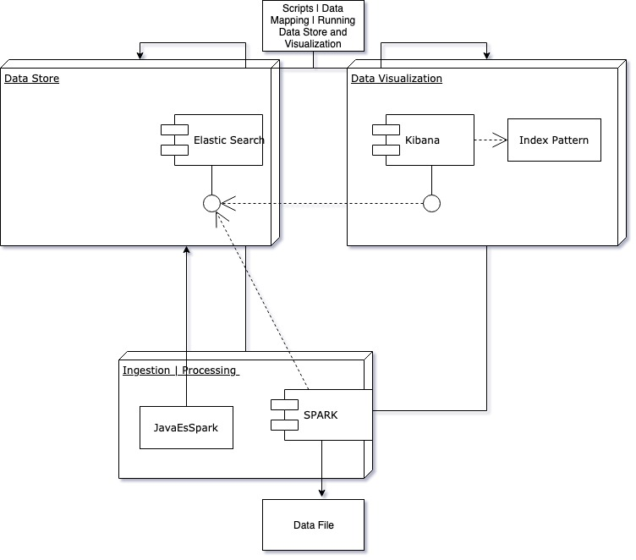

**[Figure 38: Architecture Diagram | Components]**

The architecture of the solution, as shown on **Figure 38**, revolves around three main software components.

First is the Big Data ingestion, cleaning, aggregation, processing and analysis of the data. It is its own custom build component and execution unit of work. It has already been discussed how it operates in abstract terms. Within the section Information flow, there would be provided more in depth look into the execution points of work. This component is both input and output generating computational mechanism. It serves as both the Data Ingestion and Processing Layer.

The second component is the Data Store Layer. It acts again as both input and output data exchange point. Given that we have already provided its internal structure, it would be open for communication via pre-configured software protocol means. The Data Store is also its own software component that can reside within the same network or/ and environment as the Data Ingestion/ Processing or not, as long as the communication address protocols have been set between both.

Third is the Data Visualization Layer. It is its own component and as well as the Data Store Layer, is not custom build, but a software solution configured to be used as is. It can only consume data input from a Data Store and does not communicate with other software components. It can be on the same network or/ and environment as the Data Store, but needs to be pre-configured before deployment/ usage. The Data Visualization and Data Ingestion/ Processing are the two components that do not interact with each other directly, but are by-products consumers of the solution’s information flow. They both can act independently and do not rely per say on each to operate.

## Data Modelling

One of the most important aspects of the software solution is its data. The way the data is defined, structured and distributed as communication patterns among the components.

The data coming to the Data Ingestion/ Processing Layer is in an unstructured format. In order to handle it correctly and address the domain analysis needs, it has to be structured in certain terms.

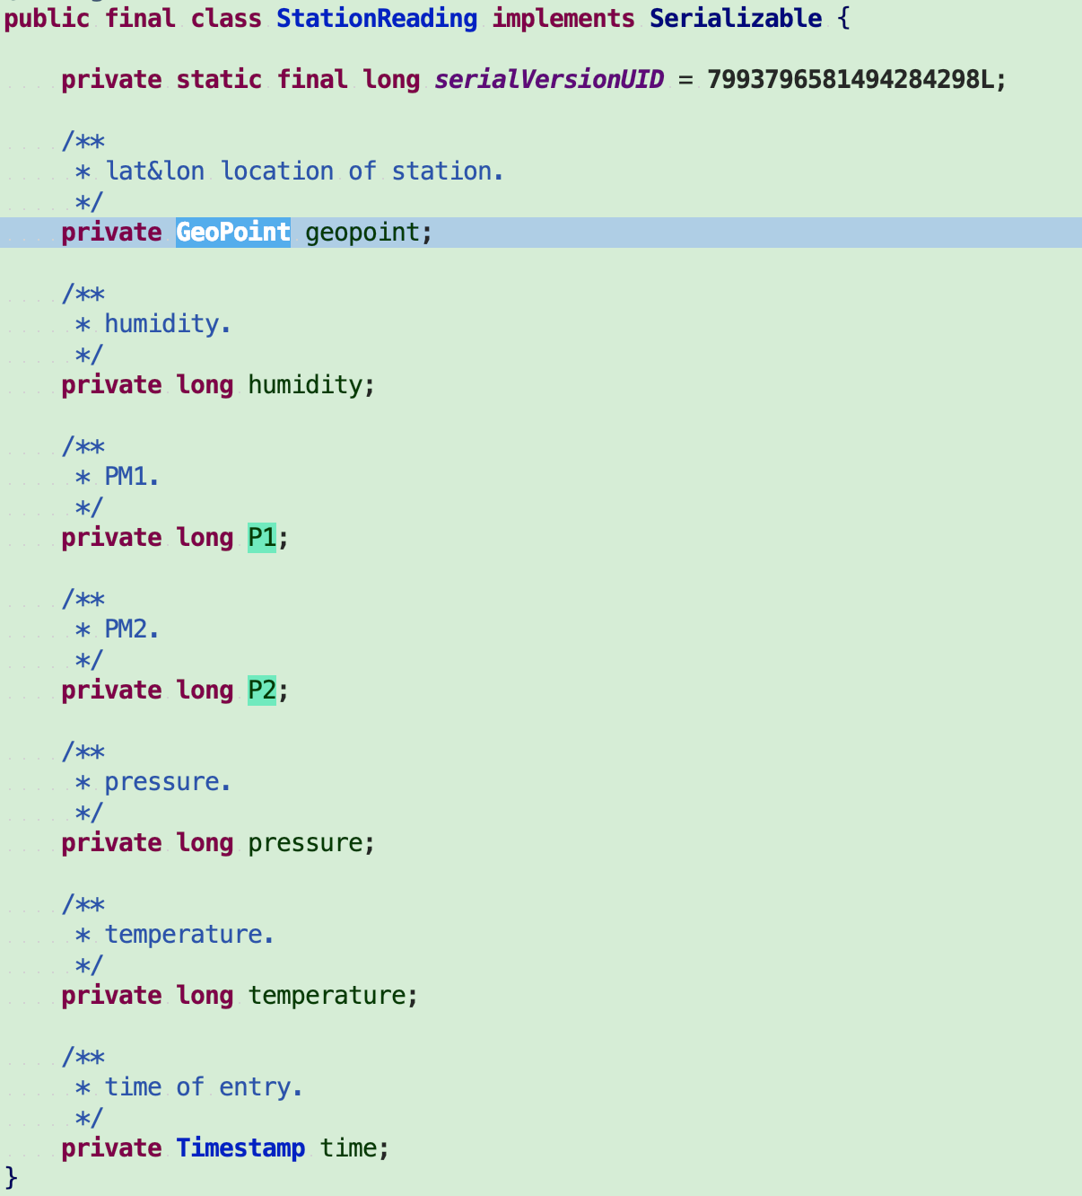

**[Figure 10: Domain Data Model]**

As visible from the above **Figure 10**, we have the main Data component class named after each individual property value record to be analysed as part of the larger domain model - StationReading.

The fields are self-explanatory as their names and comments suggest. They cover the data recorded per single transactional raw data point collected and to be processed.

As the domain area defines this aspect, what we are interested in are:

* the type Timestamp - **time** this record was done
* the long types **temperature** and air **pressure** recorded at it
* the long types **P1** (PM 2.5) and **P2** (PM 10)
* the long type **humidity** and custom type Geopoint **location** of the recorded reading.

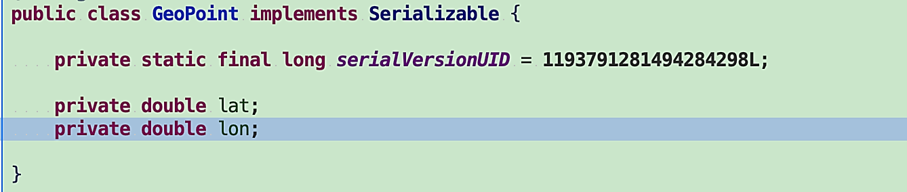

**[****Figure 11: Custom GeoPoint Data Model****]**

The GeoPoint data class, as shown on **Figure 11**, is in need to be custom made due to certain specific workings of the Data Store and it’s auto configuration for data types mapping. The Data Store can automatically map all the data received per StationReading, but has limitations with special types like GeoPoint (Geographical Point) and thus it needs to have it defined in simple programmatic terms as **lat** and **lon** double values.

The Data Store is to receive such json structured byte stream of communications in the format for record abstracted as StationReading. As already above discussed, the Data Store needs to have its structure defined before usage in order to correctly apply the information pieces in usable means. It reflects directly the Java data definition thus far elaborated on and represents the following from within a script file named **createStationsIndex**, as shown on **Figures 12 and 13**:



**[****Figure 12: Curl Command Pattern for Data Store Persistence****]**

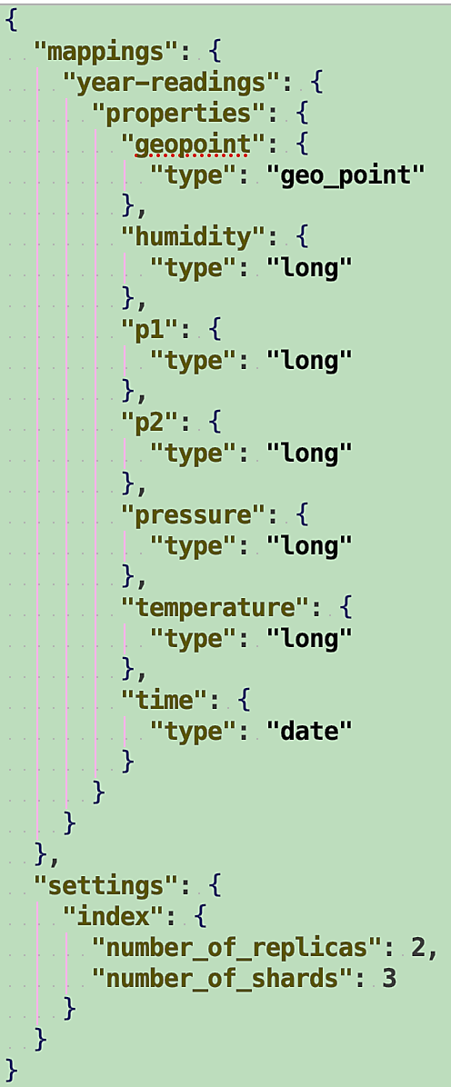

**[****Figure 13: Data Store Index Definition, Curl Command Payload****]**

The first provided on **Figure 12** is command line executable using the previously mentioned curl tool-set. The second, as shown on **Figure 13** is the actual data definition for the Data Store as a payload. It has the persistence structure set with basic settings and naming of the abstraction storage location as year-readings - all in accordance to the main data definition structure as stated above, an index called stations-year-reading. There is also configuration for data scalability, defined as two replications of the data index and three separate load-balancing instances.

It is specific to this data store to have these settings as such and json format defined.

As a side note, like most NoSQL Data Stores, ElasticSearch has its own way of storing information within and naming of its abstractions that follow it, similar to what a traditional RDBMS has. **[****28****]**

Using the data structure and with the agreed upon naming convention, the Data Processing Layer via REST API http call communicates in bulk batches the information pieces of StationReading to the Data Store. Thereupon the Data Store handles the internal distribution of data pieces and is ready to be called upon/ queried almost immediately.

## Information Flow

The Information flow of the software solution is quite direct. It can be represented using a simple lane flow Diagram for the general use-case, as shown on **Figure 14**:  
  
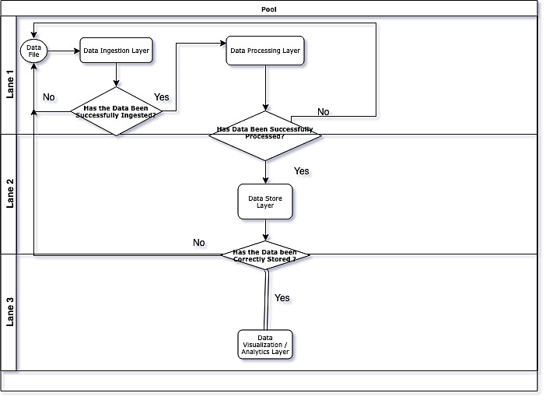  
**[****Figure 14: Lane Flow Diagram of the Air Quality Solution****]**

There are several decision making points that are happening upon the software solution’s execution path as seen from the diagram.

First, there is a Data File ready for ingestion, if successfully done in the Ingestion Layer, we then go to process the data in the Processing Layer. If the Processing layer is successful in its operations, the data is ready for communication further, else if not, the processing needs to happen from the Data File and Ingestion Layer once again - all done within the Spark Framework.   
The approach here and to be used once again is called “all or nothing”, derived from the cryptography principles **[****29****]**. In essence, both operations are binary in their nature as any loss of domain state defining data would be undesired and cannot be considered to be domain analysis useful.

Second, the data should be now being communicated by the Processing Layer to the Data Store Layer. From here the flow comes to data inspection end result and if successful then the Data Visualization and Analytics Layer can use it, if not, we have to start from the beginning following the “all or nothing” approach.

Third and finally, is the Data Visualization and Analytics Layer. In this layer we use the processed and communicated to the Data Store information pieces for Visual analytics purposes. It allows for various methods of data visualization techniques and analytics using domain based statistically relevant definitions. There would be further discussion into the visualization pieces as Interfaces to Interact within the coming sections.

There are two script files to be used as supporting the information flow given steps. One of them has already been covered, the **createStationsIndex**, while the other **deleteStationsIndex** simply perform as its name suggest - deleted the Data Store defined structure for the air quality domain data. They are to be used as needed, in sequence, every time we are at the Data Ingestion beginning - Data File step.

## Means to Interact with the Solution

The software solution is done as is, with no UI, but for configuration and programmatic interaction via IDE/ text editor and in concrete terms the configurations and Data File naming. However, the way to perform the Visual Analytics and Data Store inspection, it has to be done via a form of API UI from the software components.

For ElasticSearch, the data structures created are browsable, called indexes, via a well-known pre-defined localhost:9200 application address, as shown on **Figure 15**:

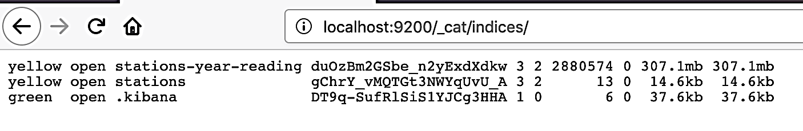

**[****Figure 15: ElasticSearch Indexes Browsing****]**

And more specifically visually inspect all indexed data piece elements, as shown on **Figure 16**:

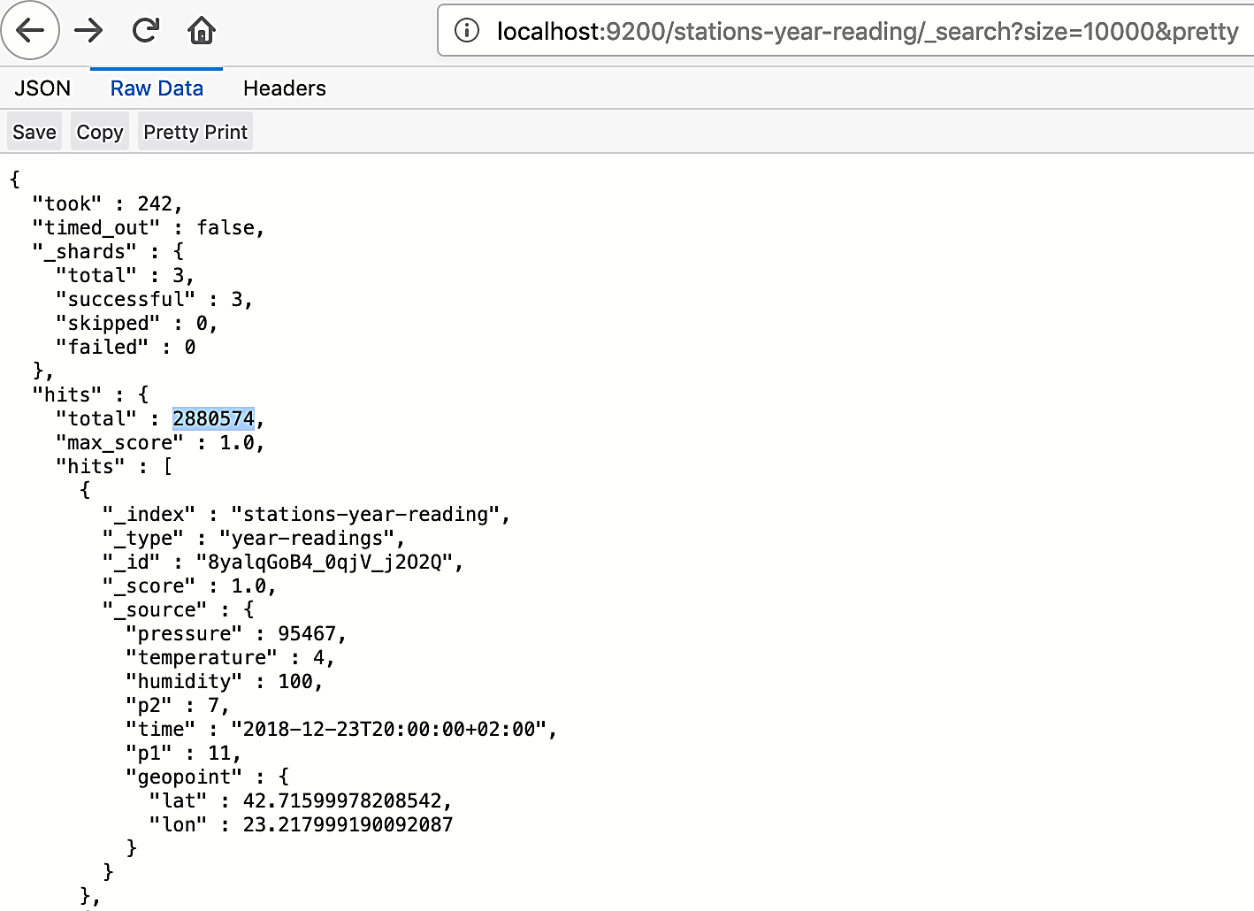

**[****Figure 16: ElasticSearch Domain Index All Data Display****]**

Kibana provides a more user friendly GUI to browse the Data Store, via the Discover Functionality - it also uses a well-known pre-defined localhost:5601 application address, as shown on **Figure 17**:  
  
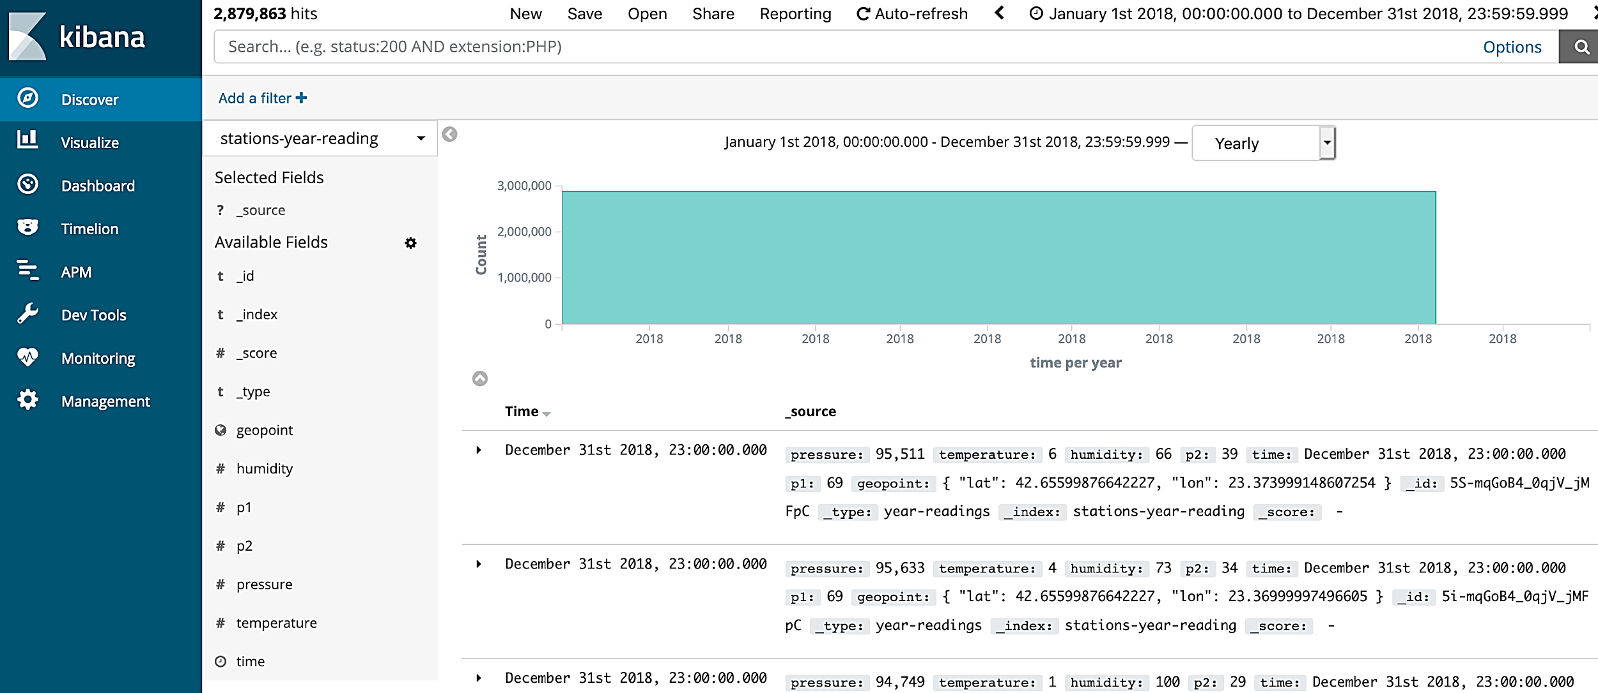

**[****Figure 17: Kibana Domain Index All Data Display****]**

However, to use the data pieces from the Data Store, it is first needed to virtually find/ declare them for use via the Management option-menu form Kibana, as shown on **Figure 18:**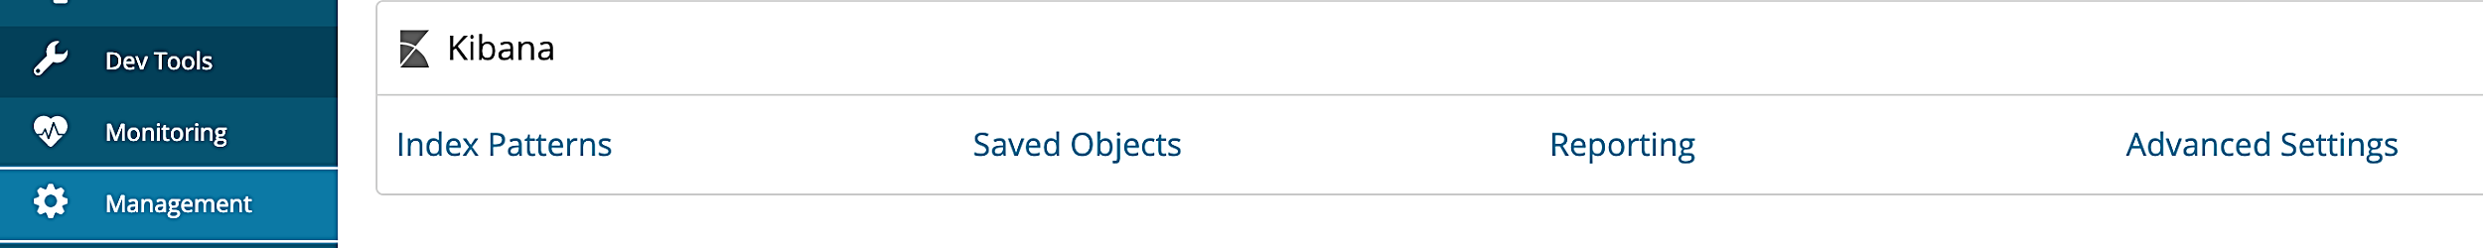

**[****Figure 18: Kibana Index Pattern****]**



**[****Figure 19: Kibana Create Index Pattern****]**

Then upon select the “+Create Index Pattern”, as shown on **Figure 19**, and find/ declare the already known data structure, as shown on **Figure 20**:

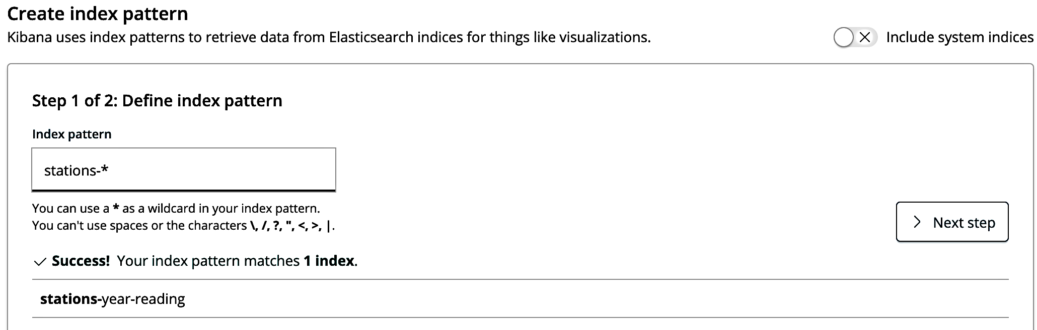

**[****Figure 20: Kibana Index Pattern Matching****]**

After we have successfully applied for usage the index data structure, we can proceed to the “Visualize” menu and delve further to create the base model for Data Visual Analytics from the available for selection templates, as shown on **Figure 21**:

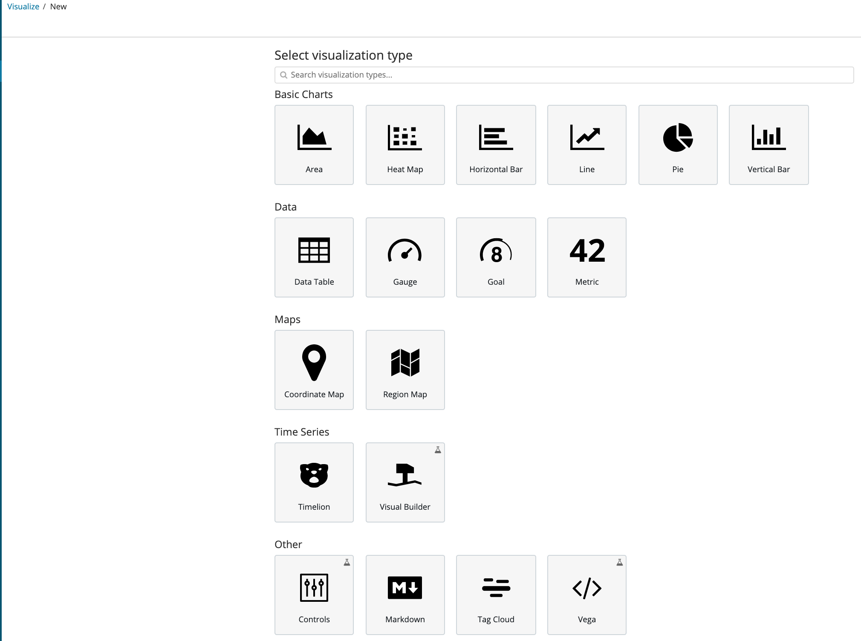

**[****Figure 21: Kibana Visualization Templates****]**

Within the next chapter there would be more in depth overview and mentions of the used within this work Visualizations for analysis and their Analytics based functionality implementations using the domain indexed data.

# Solution Implementation and Use Cases Definition

It has been discussed in the previous chapters the architecture, means of working and software component’s inter-communication patterns. All these abstractions and layers of information flow are defined by the implementation means within a distributed environment of execution.

Each software component has its own design of execution that would be looked upon further with considerations for the domain use-case focus - Visual Analytics of Big Data for Air Quality.

The software solution consists, as already covered, of three components that are deployed/ integrated in accordance to their usage. To follow are more concrete provisions based on the information flow and also further details on the given mechanisms applied.

## Design execution of the Solution

The software solution has prerequisites of running that would be briefly overviewed and later further expanded upon within the System Integration section.

In continuation of the Information Flow previously provided, it needs to be defined the usage of Docker and its design created to facilitate the operational usefulness of the Data Store and Visual Analytics Layers.

Docker provides for the creation of an execution file descriptor mechanism called **docker-compose**. Within such named file and using it with Docker provided keyword executables, the two layers have been defined as services, as shown on **Figure 22**:

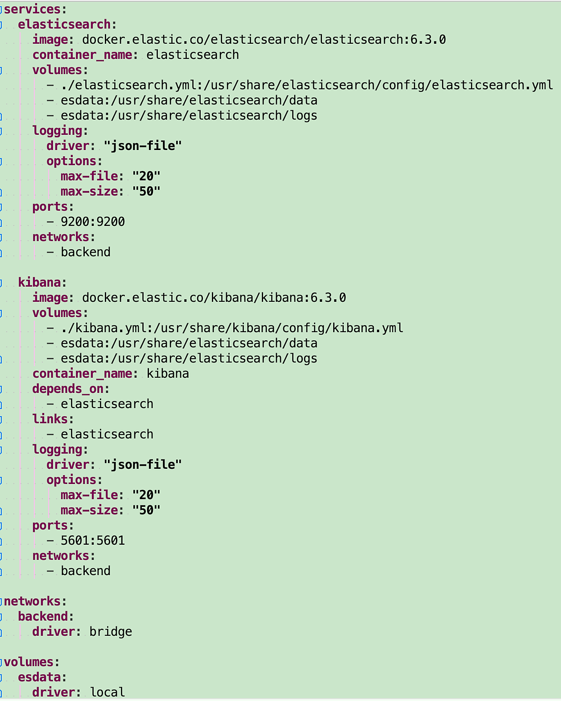

**[****Figure 22: Docker Compose Elastic Services****]**

The services follow a general well established declaration design pattern **[****30****]** in addition to two basic custom made configuration files named per the respective service with added logging file for each, as shown on **Figures 23 to 25**:

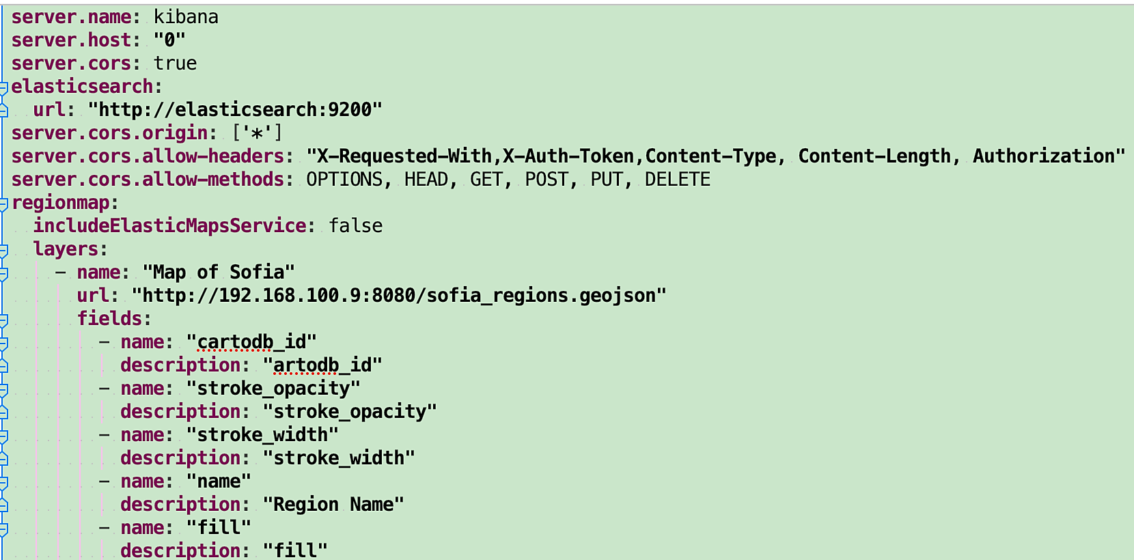

**[****Figure 23: Kibana Configuration File****]**

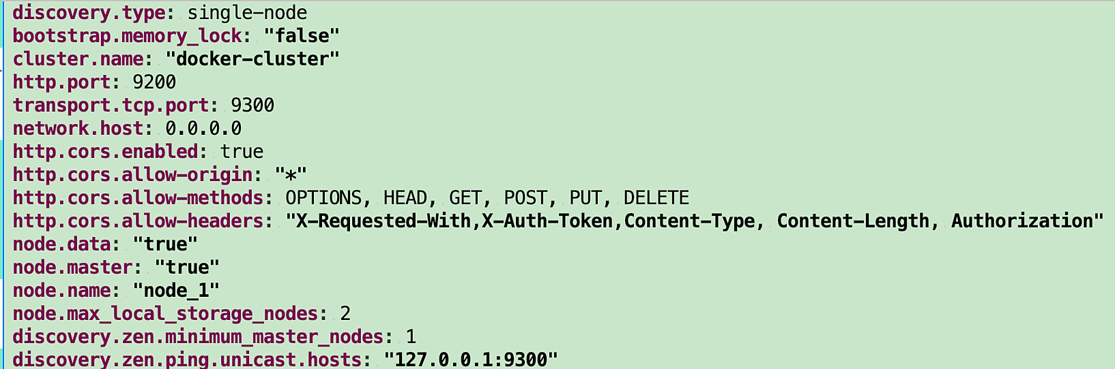

**[****Figure 24: ElasticSearch Configuration File****]**

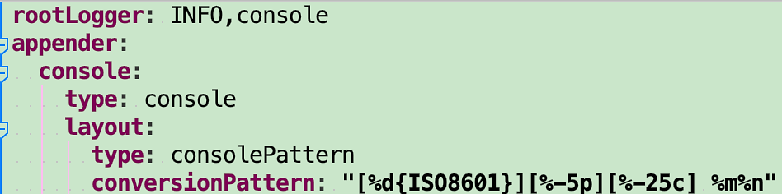

**[****Figure 25: Logger Configuration File****]**  
  
There are two executable script files within the same file/ solution level of information storage that perform starting or stopping them two services per OS specific execution environment. The files are named **unix_start_es_kibana**/ **unix_stop_es_kibana** - **windows_start_es_kibana**/ **windows_stop_es_kibana** and via Docker they get to do their work. Having both services running, the already mentioned and provided in **Figure 12** and **Figure 13** data store scriptdefinitions are to executed.

The Data Ingestion and Processing Layer as previously discussed is done via Spark in Java. It represents a very simple execution mechanism that needs a base configuration communication and internal properties setup within a self-executing Java main method environment, as shown on **Figure 26**:

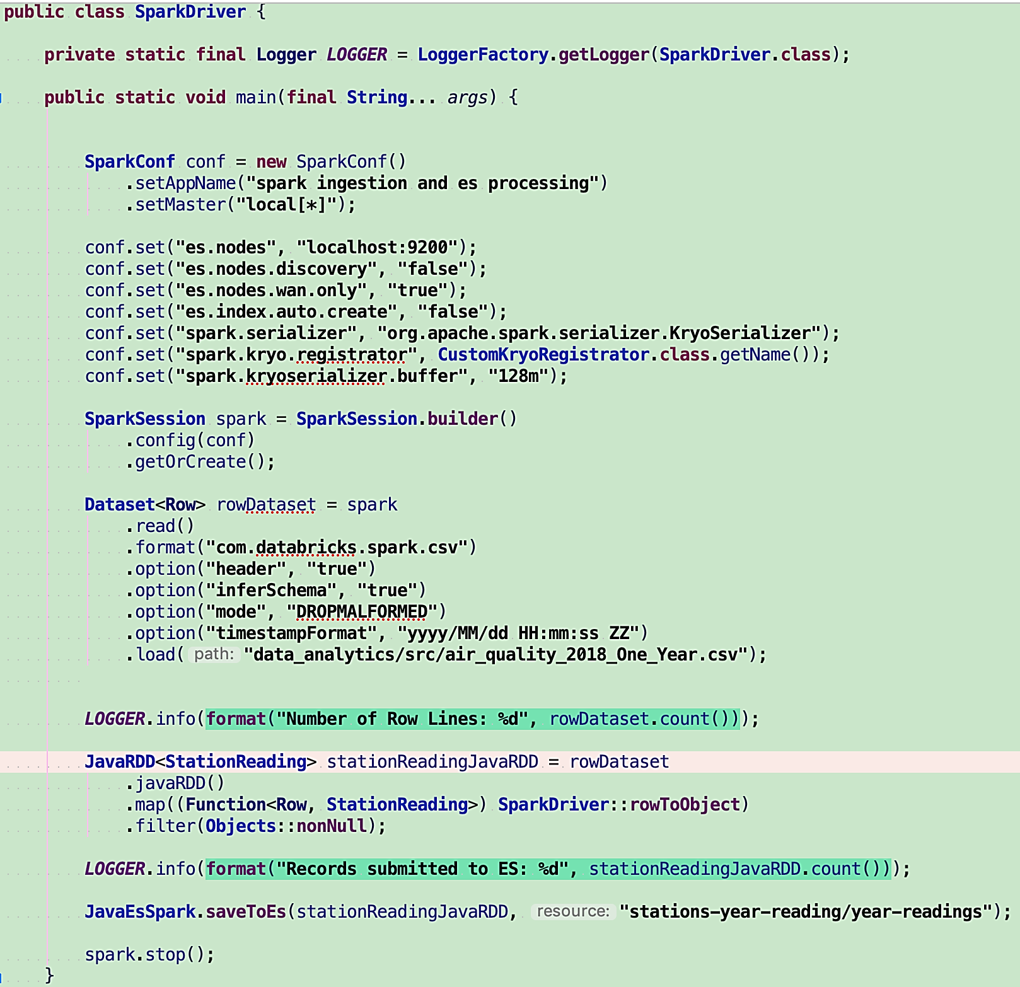

**[****Figure 26: Spark Ingestion | Processing Layer****]**

After executing the Elastic services, as a second step, we proceed to Data Ingestion. It is done based on configuration set of handling a csv file loaded from a well-known project location. Then defining a concrete date standard formatting and pruning off any non-belonging to the csv schema of majority elements types. The final result is stored within a Dataset data structure using a Row abstraction as base aggregating element.

Third step is the Data Processing, where the data structure type is called JavaRDD and the base aggregating element is our thus far discussed StationReading domain based data abstraction. Both the JavaRDD and the Dataset are Spark framework’s functional data structures that handle in distributed manner Big Data in memory.

Within the Data Processing code piece, there are two key methods and one supporting that perform domain application specific logic.

* **rowToObject** - method, as shown on **Figure 27** that takes the Row abstraction, coming from Spark SQL module, to handle line by line the row mapping to the StationReading data abstraction

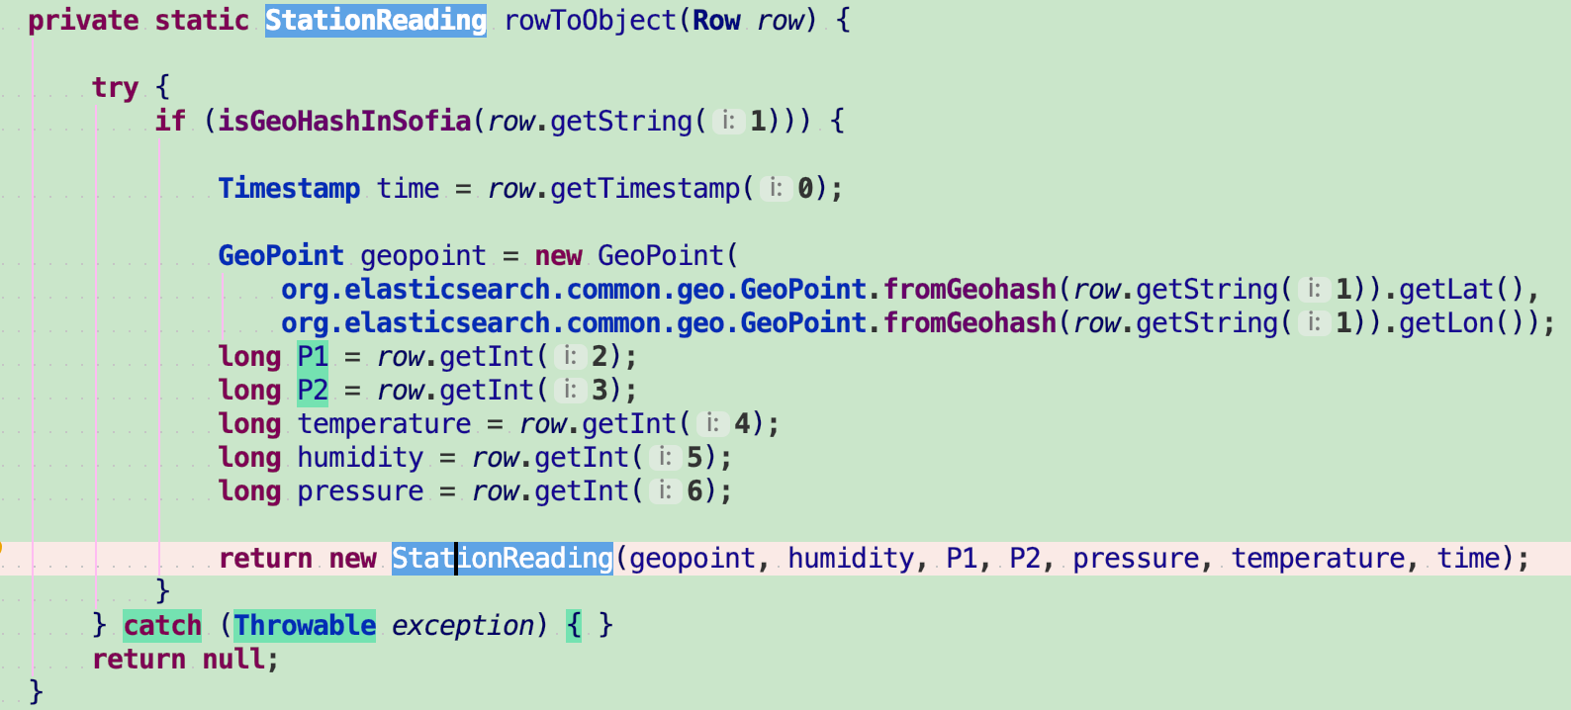

**[****Figure 27: RowToObject Method Definition****]**

* **isGeoHashInSofia** - boolean method, as shown on **Figure 28** that takes as a String the Geohash location for the given station’s record reading to be handled if within the geographical area distance of the city. **[****31****]**

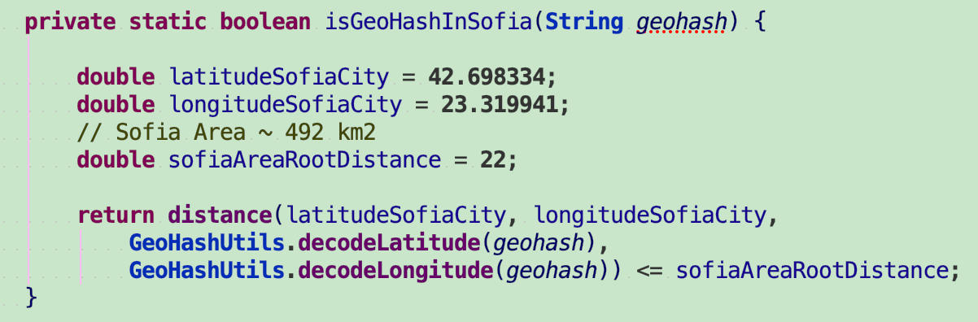

**[****Figure 28: GeoHash Boolean Method Definition****]**

* **distance** - a double value returning helper method, as shown on **Figure 29** that takes four double values of latitude and longitude - for the above said Geohash location and the Sofia city ones to do a comparison. The returned value is then compared in the calling method’s already well known Sofia city root area distance.

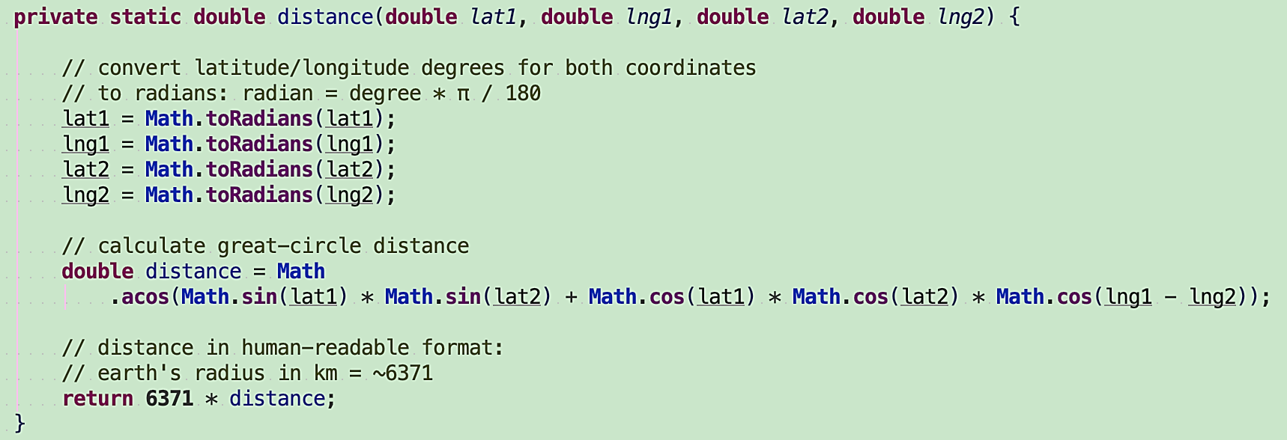

**[****Figure 29: Distance Helper Method Definition****]**

The end result of all of the above is ingesting and processing the data via Spark supported API to ElasticSearch in bulk - Big Data Rest API call for persistence, **Figure 26**, JavaEsSpark abstraction. Thereafter via ElasticSearch and Kibana, the Visual Analytics is accomplished.

## System Integration - Packaging

The Software solution as covered in part thus far is bundled of three components - the Data Ingestion and Processing, the Data Store and the Visual Analytics.

The lastly two mentioned are packaged and configured to run as they are with industry standard base configuration settings via Docker as services. They come as above discussed within script and configurable execution files per OS.

The Data Ingestion and Processing component can be packaged and run in two ways.

There is a prerequisite for both to have Scala installed and defined on the classpath/ runtime environment library execution path. Most of the Spark framework is written in Scala and albeit a JVM language, it has its own execution means - per current development environment, SDK version 2.11.0

The first way is straightforward as per the pre-defined programmed data file and store communication patterns. By using a build plugin from the dependency and software packaging solution maven. The whole software project needs to be downloaded via

Git from <https://github.com/sbaychev/data_analytics.git> and from its root **data_analytics** directory the ‘**mvn clean install**’ command performed. What we would get based on the predefined maven plugin configuration settings is “fat jar” or the longer term name “jar packaged with all dependencies” and in the current case specific - **data-analytics-1.0.0-SNAPSHOT-jar-with-dependencies.jar**

In this way the java application is packaged and ready to be executed as is, based on the JRE OS dependant it has been build with - per current development environment, version 1.8 of Java for Mac OS.

The second one is via the IDE of choice for development. Once again the project needs to be downloaded and after it the dependencies’ binaries resolved as well. Then we would need to have the above mentioned Scala SDK explicitly added to the Project Settings, as shown on **Figure 30**:

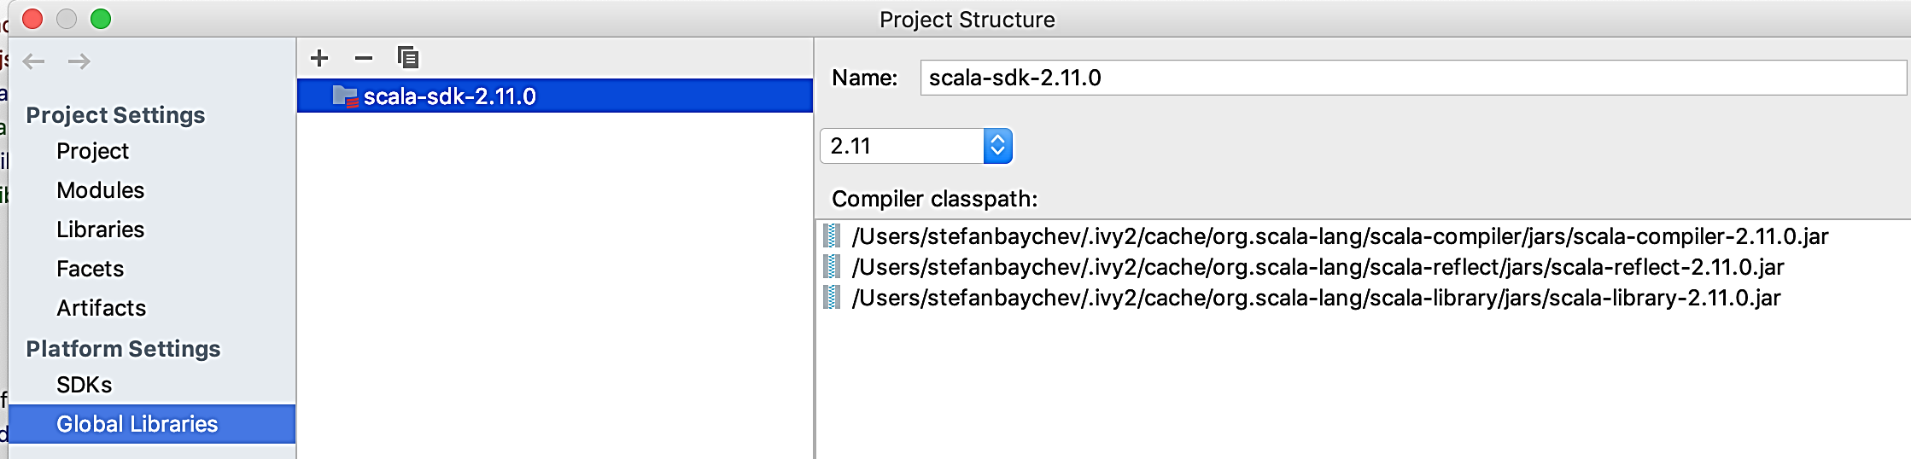

**[****Figure 30: Project Settings | Global Libraries | Scala SDK Library Dependency****]**

One more setting needs to be defined and it relates to the usage of a development library called Lombok - it is used for boilerplate object oriented and overall good development practices, as shown on **Figure 31**:

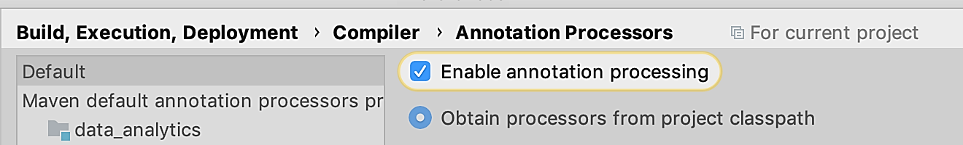

**[****Figure 31: Build Settings | Lombok Annotation Processing****]**

Then via the main class **SparkDriver** we can execute the Big Data Ingestion and Processing, as shown code wise on **Figure 26**.

All in all, there is a relatively easy deployment/ packaging mechanism to follow, step by step - from the downloaded from Git project’s root directory **data_analytics** [**https://github.com/sbaychev/data_analytics.git**](https://github.com/sbaychev/data_analytics.git):

1. Execute the Docker based script files **unix_start_es_kibana** or **windows_start_es_kibana**

~ perform visual inspection if correctly running from within their well known application localhost:9300 and localhost:5360 addresses. If all good, proceed, else investigate and correct.

1. Execute the mapping | scalability script **createStationsIndex**

~ perform visual inspection if correctly executed via the http://localhost:9200/_cat/indices/ or/ and from the Kibana GUI. If all good, proceed, else investigate and correct either via the **deleteStationsIndex** script or other means.

1. Execute the Data Ingestion and Processing

~ perform inspection of end result running, first via Data Store http://localhost:9200/_cat/indices/ or/ and from the Kibana GUI. If all good, proceed, else investigate and correct. If need be corrections to be performed, first execute the **deleteStationsIndex** script and proceed to the beginning of step 2.

1. Use the Visual Analytics Platform - Kibana

~ follow **Chapter 5.4** description and perform as needed Visual Analytics usage.

## Test Scenarios, procedures and planning

From the perspective of current domain use-case needs and the overall developed functionality based on it, there are no concrete test scenarios to be covered. It would not be meaningful for any of the Data Ingestion, Processing, Storage or Visualization Layers to have such at this point of time. In future terms, once more clearly defined use-cases and maybe with streaming functionality support there would be such concrete needs that would cover the respective functional and non-functional needs. Currently the only possible and bearing any meaning tests are health check deployment and execution ones. However, it does not make much sense unless doing a full automated deployment within a commercial - production environment. All of the above mentioned layers perform their functionality as is, in a binary sense. Any custom logic in existence is limited to the domain use-case that is based on user input approval for consistency or correctness as a whole.

## Analysis of the provided Functional Means

All of the thus far covered functional provisions reflect the domain specific and end goal identified priorities. They are in line with the current needs and future further development, alongside considerations for support and maintainability. The development hardware configuration is good to be provided in respect to the developed functionality:

* Unix/ Mac OS, Intel Core i7 2.5 GHz, 16 GB DDR3 RAM, SSD HDD

It has to be kept in mind that each of the software components require certain HDD, RAM and CPU considerations. They are dependant per technology.

Because all of the technologies used do a major part of their computational work in-memory, a good rule of thumb is to consider 2 times the data payload for RAM and then spread out per running component. In a sense each of the 3 software components require at least 3GB of RAM for their workings at any given time, with consideration to be expanded to 5GB if all of them are running simultaneously. Docker would provide the management for the in-memory, HDD and CPU considerations for the Data Store Layer and the Data Visualization. For the Data Ingestion and Processing Layer, there is just the one-time consideration of heavy in-memory load and there-upon Spark handles the back pressure. There is no specific need for JVM running configurations, but to speed up the data handling with the advised at least 2 times the payload Heap Memory buffer - on top of the base ones.

The Data Ingestion and Processing Layers are able to handle Big Data domain files as a unit of work and batch process it with custom logic implementations within a distributed environment. They are designed and implemented in adherence to be easy to use, maintain, to be developed on further and execute in a consistent and durable time frame. Both Layers’ functionality executed over 100 times shows a consistent 5-8 minute running time from beginning to posting to the Data Store for a 260 MB domain data file. The overall memory footprint is in the range of about two and a half times the data file size. Similar running times and memory footprint were exhibited with 5 times larger data file sample.

The Data Store Layer is able to handle as per functional specification domain needs, Big Data storage and analysis within a distributed environment.

The Data Visualization and Analytics Layer provides Visual Analytics capabilities via diverse set of templates like graphs, maps, charts and time series.

The so far stated layers and software solution’s execution points have been thus far well covered, but not at the concrete use-case needed level for the Visual Analytics. Here to follow within the Analysis section would be done so.

There are several picked and custom made created visualization based on the Big Data gathered for Visual Analytics means. Each would cover sample of a use-case Analysis based on the domain use-case for Air Quality on top of Statistical means.

1. Vertical Bar Type - “Maximum PM 10 with overlay of Standard Deviation in terms of the Average Daily Values for 2018”

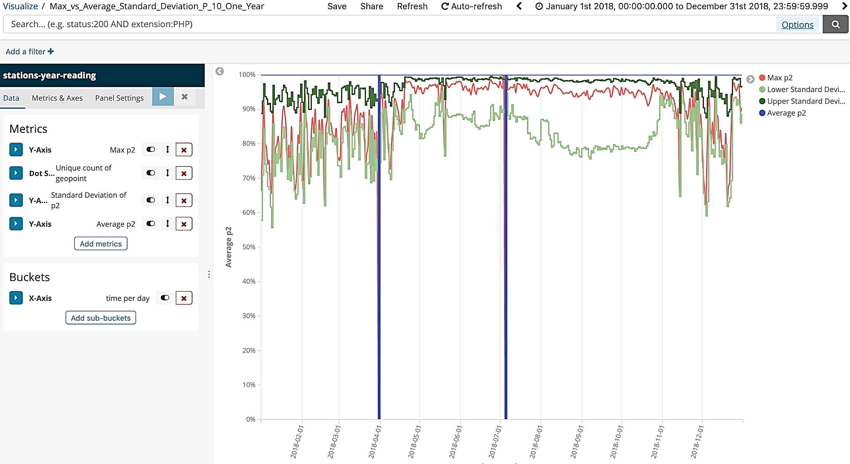

**[****Figure 32: Vertical Bar Graph with Multi Layer Value Properties****]**

What is shown on **Figure 32** is an X-Y based Coordinated Vertical Graph with two plot lines:

* X - Axis - a Yearly Histogram with a Daily Day Frame for recorded values
* Y - Axis - an Average PM 10 values recorded for the given date-point of time

The property values to be Analysed as information pieces within them two scales of cross section are:

* Max p2 - Maximum PM 10 value recorded for the given date-point of time
* Average p2 - Average PM 10 value recorded for the given date-point of time
* Lower Standard Deviation - 2 Standard Deviations down Normal Distribution from the Mean/ Average value recorded for the given date-point of time
* Upper Standard Deviation - 2 Standard Deviations up Normal Distribution from the Mean/ Average value recorded for the given date-point of time
* Unique Count of Geopoint - Statistical means for calculating amount of unique stations that this reading relates to, as we can have multiple daily recordings per single geopoint.

These provided base-point statistical measurements govern an Analysis derived context coming from the Mathematics branch of Statistics. A very basic knowledge of data gathering and analysis performance on it is data uniformity, existence and distribution. How the data is distributed in consideration to the mean is the one of the prime postulates of Statistics and specifically the three Sigma rule/ Gaussian Distribution **[32]**. What we would aim and for practical considerations, is to observe how the domain specific PM 10 data is distributed in accordance to the mean using 95% distribution of 2 sigma. A good and Statistically known data set applied on with considerations for Normal Distribution gives understanding of the data’s cohesion. The higher the data cohesion around the mean within the given standard deviation, the more granular and clear trend can be derived from. The lower the data cohesion and dispersion about the standard deviation, the more need for further analysis and data inspection of the off-falling data points. Such Analytics with the provided Visual aided means would give a quality criterion of the data and provide for certain conclusions or/ and suggestions to be made.

Visible from the above image is: the 100% blue line where the Average p2, the mean PM 10 is the focal point and with relation to the light/ dark green PM 10 standard deviation. Within them is the Max p2 PM 10 in red colour. The plotted inter-relations values are independent of placement, but bear a percentage relation and placement in accordance to the mean PM 10.

Regardless if there are no concrete extractions of numerical values comparison for a given date-point of time, there are still a few clear cut trends discernible.

First, the beginning and end of year standard deviation distributions are skewed and dispersed in either spectrum of the mean, but the months April to November are relatively uniformly distributed.

Second, as shown on **Figure 33** following the same line of thought, the Max p2 PM 10 value tends to be abnormally distributed in either end with heavy weighted average distribution from the mean. The exact values can be observed either as whole or via time-frame slice selection - inspected in particular with added value of statistical data, per example November 2018 to December 2018:

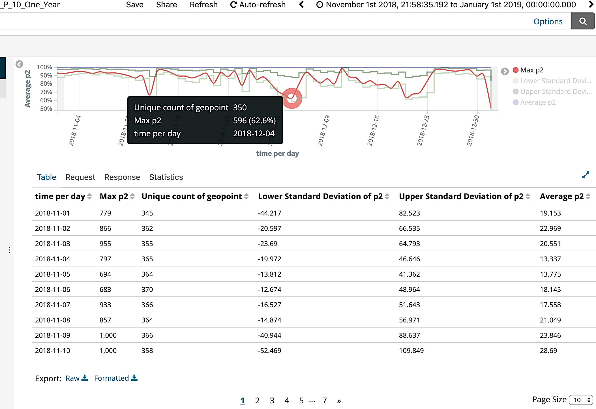

**[****Figure 33: Vertical Bar Graph with Multi Layer Value Properties | Time Slice Selection****]**

Third, as shown on **Figure 34** we can easily observe on the first given image two visual discrepancies for 31st of March and the 5th of August. These have been left out in particular as to be a matter of further analysis. Has there been no data for these two dates, has the data been incorrectly numerically recorded and thus not belonging to that time frame or there are other non-numerical quantifiable reasons. Upon inspection, it is visible that the unique number of geo data points is a positive number for both.

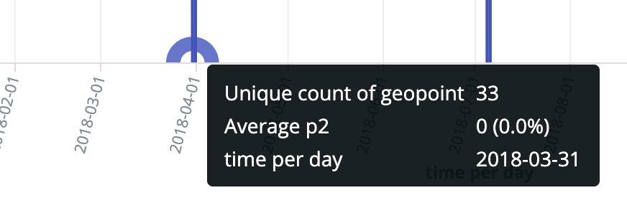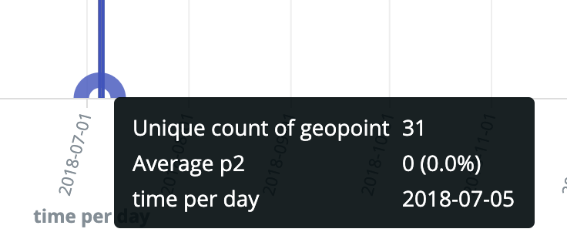

[**Figure 34: Unique Count of GeoPoint | Numerical Average PM 10**]

2) Line Graph Type - “Average P 10 for a Year”

What is shown on **Figure 35** is an X-Y based Coordinated Line Graph with two plot lines:

* X - Axis - a Yearly Histogram with a Daily Day Frame for recorded values
* Y - Axis - an Average PM 10 values recorded for the given date-point of time

The property values to be Analysed as information pieces within them two scales of cross section are:

* Average p2 - Average PM 10 value recorded for the given date-point of time

In addition, there is filter applied on the data set to display only domain relevant for analysis PM 10 values.

* Unique Count of Geopoint - Statistical means for calculating amount of unique stations that this reading relates to, as we can have multiple daily recordings per single geopoint.

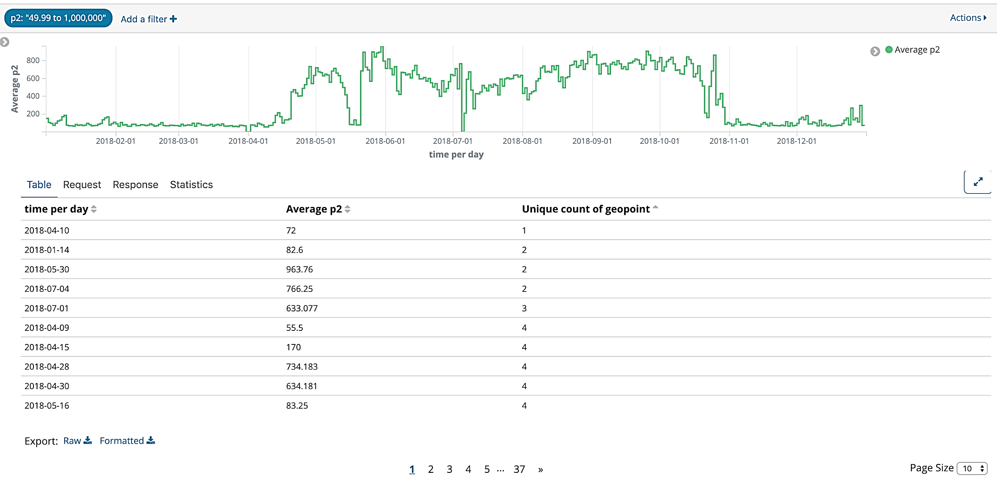**[****Figure 35: Line Graph Type | Average P 10 for a Year****]**

It is a direct domain use-case practical approach following the Air Quality Analytics needs. For this analysis, we would need to be referencing the **Table 1: Bulgarian Environment Agency, Pollutants Values and Norms [****12****]**, where the PM 10 average daily value within a yearly time frame should not be exceeded more than 35 occurrences of the 50 micrograms per cubic meter property value. It can be easily seen from within the given results, there are more than 360 such occurrences within a year recorded, from more than 1 unique data-point.

It is also visually clear that, if not counting for a few spike values, the months of January to 2nd half of April and November to December have similar average values distribution in the range 50-150 micrograms per cubic meter - 5.5 months. For the other 6.5 months of the year 2nd half of April to November, the average values have huge spikes between borderline in limit air quality property values and times more than the average daily limit - with consistent time-frames of such over the top readings.

Having seen and done some analytics over the visually presented data for the graphs 1) and 2), there can be some preliminary conclusions made.

There are months throughout the year where majority of the average PM 10 is very high on a consistent manner - April to November.

Within the months of January to 2nd half of April and November to December, the average values above the health hazardous limit are relatively consistent with one another, but accounting for the most abnormal and highest maximum PM 10 values recorded.

Having both Graphs as base points for comparison and analysis on just the PM 10 pollutant and being able to make reasonable statistically bearing meaningful conclusions, provides for further in depth analysis and decision makings by domain experts.

3) Coordinate Map - “**Figure 36:** One Day P 10 Unique Data Points - Heat Map Filter” and “**Figure 37:** One Year P 10 Above Average Filter - Unique Data Points in Sofia GeoGrid”

Both Visual Analytics tools are Maps with pre-defined criteria for unique geopoint locations.

* Unique Count of Geopoint - Statistical means for calculating amount of unique stations that this reading relates to, as we can have multiple daily recordings per single geopoint.

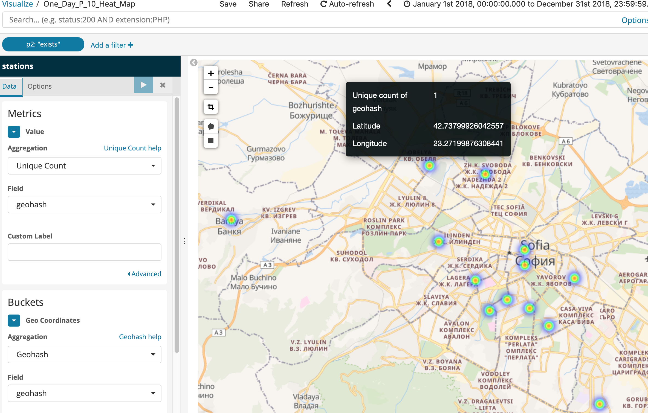

**[****Figure 36: One Day P 10 Unique Data Points Filter | Heat Map****]**

The aim of the first one, as shown on **Figure 36,** is to pick a single day of the year. Then, pinpoint the unique locations of station’s reading recordings on the map of Sofia, using a Heat Map filter for PM 10 values.

It can be further expanded upon within a pre-defined time frame or value properties filtered for display, per domain specific analytical needs.

In this concrete use-case it is easy to locate where the majority of the unique stations are and what geographical area of the city they cover. Expanding it on in time-frame scale would further provide a statistical and other Air Quality domain meaningful correlation to be made as a unit of analysis or on previous findings similar to the ones done for 1) and 2).

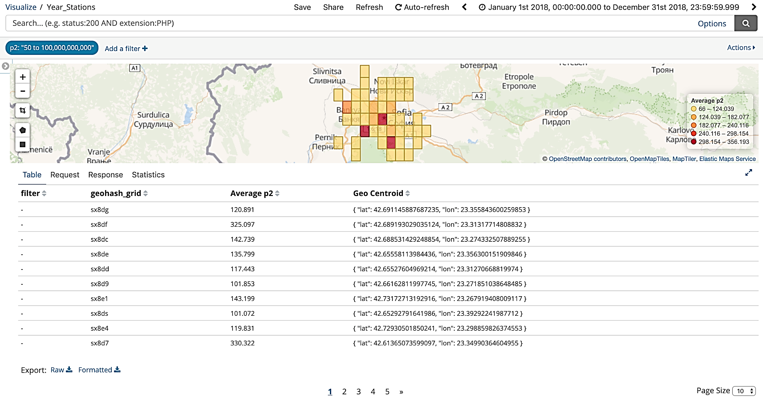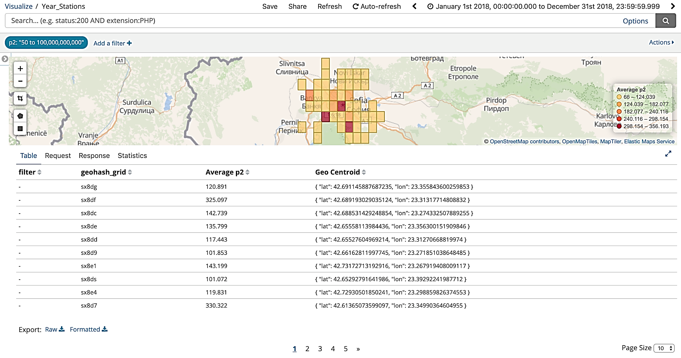

**[****Figure 37: One Year P 10 Filter | Unique Data Points | GeoGrid****]**

In the above provided **Figure 37,** shaded geohash Grid Map, there are two value properties used for Analysis:

* Average p2 - Average PM 10 value recorded for the given date-point of time

In addition, there is filter applied on the data set to display only needed for analysis PM 10 values.

* Unique Count of Geopoint - Statistical means for calculating amount of unique stations that this reading relates to, as we can have multiple daily recordings per single geopoint.

As already covered within the Line Graph in 2), we can now see on a visual map representation of the city the same filtered for PM 10 average daily value within a yearly time frame. In this way, now we can directly filter within the shown table for the property values we are interested in as a whole to browse within a given region or as statistical units of majority correlations based on a region the data is found.

The Geohash grid map and the Heat Map are very handy and useful Visual Analytics tools to be used for Analysis as they provide a special and geographical meaning to the data in a digestible with statistical numbers way.

All of the thus far discussed in 1), 2) and 3) Visual Analytics applied templates can use the full spectrum of the Air Quality Big Data at hand. It can be applied directly as points of analysis or as means for analysis on other such value properties. There are many more Visual Analytics templates to pick from as already said, but depends on the domain use case and Analytical needs to be done.

Albeit all the good and quality Analytical capabilities stated thus far, it is good to be said that there are certain data limitation in provisioning the value properties within the Visual Analytics templates. A value property that is not numeric or of certain numeric type cannot be used or displayed alongside a data record that is being analysed on.

* It is not possible for a character based field to be displayed along a record either on analysis execution within a graph or a data table.
* There isn’t a straightforward way to display per say a list of geohash locations for a given analysis point of average PM 10.

## Deployment Mechanisms (technical needs, pre-conditions and usage)

Most of what is needed as Deployment needs has been discussed at length and detail within **Chapter 6.2**. However, it is good to be mentioned once more in concrete terms the technologies needed at hand for the solution’s usage needs:

1. Current Java SE version 8, JRE and SDK
2. Scala SDK version 2.11.0
3. Docker Desktop CE version 2.0.0.3 (31259)
4. Curl
5. Apache Maven
6. Git
7. An IDE of Choice - IntelliJ IDEA
8. Internet

All of them are open source, easily available and ready to be used via binary executables or/ and as packaged OS specific solutions. If need be, there are easy setup instructions from their respective websites and huge online community from within their own supported web forums.

# Thesis Summary

The Air Quality domain is a very important topic of analysis and information gathering, because it is directly related to our wellbeing, our health. It has immense implications to our quality of life and longevity. There is a good availability of Big Data software solutions that can sift through all the high volume, velocity and rich in variety domain data to generate value. In this sense there is a need for Analytically driven decision making. This decision making is much easier accomplished, if merged with Visual Analysis of the Big Data gathered. In the case of the Air Quality domain area, there is a tremendous value added benefit for the people doing Analytics to be able to map out or derive at relationship criteria matching on both geographical and pure data scale. Fusing the domain specific value properties with visual analytical means identifies much faster developing trends. It provides for interpolation of data sets to generate future/ past patterns on multi-value properties considerations for specific time slices and geo-spaced regions.

## Summary of the initially defined goals

The initially set goals of the master thesis would be discussed as already covered thematically and provided for in details.

First item of order to cover, related to the domain area of air quality and existing solutions within it for analytics. It was well established what are the categories of pollutants within the air. How the air quality is measured and to what degree the world environment monitoring agencies are analysing and storing the data. Lastly said relates in part also with the available domain area software solutions, because they are driven by necessity or lack of such. Overall it was well affirmed how in particular the Bulgarian Environment Agency handles its data and analysis definition. Albeit there are some available software solutions in web accessible format, there is not enough flexibility or reusability built into them and neither accessibility to analytical decision making - different than the narrow scope defined within them.

Second point is the technological and main aspect of workings. It was clearly set that for a technology to be selected for implementation as a domain solution, it has to cover certain quality criteria. The quality criteria defined relate to the usability, practicality, future development and support. A broad overview of the technological domain area was provided as well, in order to gain insight into the technology selection process. As a whole, the decided upon technology stack indeed covers the quality criteria defined and adheres functionally to the domain needs.

Third point in the execution plan of pre-defined goals relates to the analysis of the requirements to achieve a thorough domain driven Big Data Visual Analytics solution. This part relates to the definitions set for arriving at the right decision makings for domain analytics. It also relates to correctly identifying the information flow inter-dependencies between the different components needed for the technical execution of the solution. Achieving this point provided for easier and streamlined workings on the technical aspects of the implementation.

Fourth point relates to the domain data definition. The key aspect here is how the data is to be analysed within the domain constraints and thus what considerations need to be made in terms of Big Data handling and storage to achieve this. The successful achieving of this goal created the backbone means for performing Visual Analytics at a later stage.

Fifth point relates to the architectural and further definition of the information flow patterns within the solution’s components. The creation of well-defined and established layers of inter-relations is another equally important goal. Having such patterns laid out, allows for the software implementation to have clear boundaries for development.

Sixth point relates to the actual implementation of the software solution. Taking into consideration all of the thus far set goals and executing upon them in code. Achieving this goal was as hard and cumbersome process as providing the framework for it. There were many obstacles and unknown paths of software engineering that had to be taken into account. Having experience in some of the technologies allowed for better and domain applicable software components creations. All of the previously defined and achieved goals provided the right scope and guide path to engineer the software solution.

Seventh and final goal point relates to the Analysis. It was first needed to have the means for analysis defined. In what way the Visual Analytics for Big Data Air Quality is to be performed. Then as above given all of the previous steps leading to the creation of the solution and thus to the Analytics part. In this part, the main goal to accomplish is a robust and practical analysis of domain specific data. The validation of this point via derived Visual Analytics and the overall work done within the thesis is linked to providing a useful solution, and indeed such was created.

## Means and Ways for updates or/ and upgrades of the solution

The future updates and upgrades to the solution would very much depend on the analytical needs and usability needs. The way the solution has been constructed as software components, provides for upgrades in various directions keeping in mind a broad spectrum of functional and non-functional designs.

Immediate workings can be done to address a several times bigger data set without need for configuration setup, as long as the data model supports it. If we are in need to change the data model with additional value properties, it is a straightforward process to simply change the Java model class, the data processing and data mapping within the data store. A very opaque and non-obtrusive process to do, as already described at length within the **Design execution of the Solution** chapter.

Other logical changes come to the analytical and visual parts, where many other templates for analysis can be further upon put to use.

Both ElasticSearch and Kibana offer even deeper insight into the data with built in pattern matching algorithms that can be queried upon.

It can be provided for various regression and data forecasting modelling via Kibana.

From technological standpoint of view as already covered all of the 3 components can be scaled easily both vertically and horizontally.

Another technical aspect of consideration is to further improve upon the application deployment mechanism. To have a more automated delivery mechanism via abstracting the Data Ingestion | Processing Layer to a publicly available archive and providing for executable/ extractable data as a file or data flow.  
 A possible way for future development stems from streaming data points, to develop further the Data Ingestion | Processing Layer to handle such data loads.

There are various ways that the current software solution can be used as is, with some or none upgrades. It all depends on well-defined criteria for either specific domain needs or other technical considerations in line with Big Data Visual Analytics.

# 

# List of Figures

|  |  |
| --- | --- |
| **Name** | **Page Location** |
| Figure 1: AirTube Display Criteria | 11 |
| Figure 2: AirTube Bulgaria Stations | 11 |
| Figure 3: AirTube Bulgaria Sensor Data Display | 12 |
| Figure 4: EEA Agency Air Quality Zones | 13 |
| Figure 5: EEA Agency Air Quality Statistics | 13 |
| Figure 6: EEA Agency Air Quality GIS | 14 |
| Figure 7: Bulgarian Environment Agency, Daily Chart of above Limit Pollutants per Station | 15 |
| Figure 8: Bulgarian Environment Agency, Yearly Charts for NO2 | 16 |
| Figure 9: Batch vs Real Time Data Processing Comparison | 20 |
| Figure 10: Domain Data Model | 47 |
| Figure 11: Custom GeoPoint Data Model | 48 |
| Figure 12: Curl Command Pattern for Data Store Persistence | 48 |
| Figure 13: Data Store Index Definition, Curl Command Payload | 49 |
| Figure 14: Lane Flow Diagram of the Air Quality Solution | 50 |
| Figure 15: ElasticSearch Indexes Browsing | 51 |
| Figure 16: ElasticSearch Domain Index All Data Display | 52 |
| Figure 17: Kibana Domain Index All Data Display | 52 |
| Figure 18: Kibana Index Pattern | 53 |
| Figure 19: Kibana Create Index Pattern | 53 |
| Figure 20: Kibana Index Pattern Matching | 53 |
| Figure 21: Kibana Visualization Templates | 54 |
| Figure 22: Docker Compose Elastic Services | 56 |
| Figure 23: Kibana Configuration File | 57 |
| Figure 24: ElasticSearch Configuration File | 57 |
| Figure 25: Logger Configuration File | 57 |
| Figure 26: Spark Ingestion | Processing Layer | 58 |
| Figure 27: RowToObject Method Definition | 59 |
| Figure 28: GeoHash Boolean Method Definition | 59 |
| Figure 29: Distance Helper Method Definition | 60 |
| Figure 30: Project Settings | Global Libraries | Scala SDK Library Dependency | 61 |
| Figure 31: Build Settings | Lombok Annotation Processing | 61 |
| Figure 32: Vertical Bar Graph with Multi Layer Value Properties | 64 |
| Figure 33: Vertical Bar Graph with Multi Layer Value Properties | Time Slice Selection | 66 |
| Figure 34: Unique Count of GeoPoint | Numerical Average PM 10 | 67 |
| Figure 35: Line Graph Type | Average P 10 for a Year | 68 |
| Figure 36: One Day P 10 Unique Data Points Filter | Heat Map | 69 |
| Figure 37: One Year P 10 Filter | Unique Data Points | GeoGrid | 70 |
| Figure 38: Architecture Diagram | Components | 45 |

# 

# 

# 

# List of Tables

|  |  |
| --- | --- |
| **Name** | **Page Location** |
| Table 1: Bulgarian Environment Agency, Pollutants Values and Norms | 17 |
| Table 2: Big Data Definition per Category | 18 |
| Table 3: Apache Ingestion Solutions | 27 |
| Table 4: NoSQL Comparisons | 30-31 |
| Table 5: Visual Analytics Considerations | 32-33 |

# List of Abbreviations

|  |  |
| --- | --- |
| **Abbreviation** | **Description** |
| PM | Particulate matter |
| PM 2.5 | Particulate matter of 2.5 microns |
| PM 10 | Particulate matter of 10 microns |
| IOT | Internet of Things |
| GIS | Geographic Information System |
| NoSQL | Not Only SQL |
| API | Application Programming Interface |
| JVM | Java Virtual Machine |
| REST | Representational State Transfer |
| http | hypertext transfer protocol |
| CI/ CD | Continuous Integration/ Continuous Deployment |
| OS | Operating System |
| RDBMS | Relational Database Management System |
| AWS | Amazon Web Services |
| GCP | Google Cloud Platform |
| CEP | Complex Event Processing Computing |
| KB | Kilobyte |
| CSV | Comma-separated values |
| ACID | Atomicity, Consistency, Isolation, Durability |
| XLS | Excel Spreadsheet |
| JS | Java Script |
| HTML | Hypertext Markup Language |
| ETL | Extract Transform Load |
| SE | Standard Edition |
| LTS | Long Term Support |
| IDE | Integrated Development Environment |
| bat | Batch File Name |
| bash | Bourne-again shell |
| json | javascript object notation |
| jar | java archive |
| JRE | Java Runtime Environment |

# References

1. “European Air Quality Index: Current Air Quality Information at Your Finger Tips.” European Environment Agency, EU, 16 Nov. 2017, [www.eea.europa.eu/highlights/european-air-quality-index-current](http://www.eea.europa.eu/highlights/european-air-quality-index-current).
2. “Air Quality Standards.” European Environment Agency, EU, 18 Feb. 2019, [www.eea.europa.eu/themes/air/air-quality-standards](http://www.eea.europa.eu/themes/air/air-quality-standards).
3. Crawford, and Kate. “Six Provocations for Big Data.” SSRN, 13 Sept. 2011, papers.ssrn.com/sol3/papers.cfm?abstract_id=1926431.
4. “Global Platform on Air Quality and Health.” World Health Organization, World Health Organization, 28 June 2018, [www.who.int/airpollution/global-platform/about/en/](http://www.who.int/airpollution/global-platform/about/en/)
5. EU Clean Air Policy, [www.dccae.gov.ie/en-ie/environment/topics/air-quality/eu-clean-air-policy/Pages/default.aspx](http://www.dccae.gov.ie/en-ie/environment/topics/air-quality/eu-clean-air-policy/Pages/default.aspx).
6. “AirBG - От Фини Прахови Части Към Open Data.” AirBG.info - Проект На Фондация "Код България", [www.airbg.info](http://www.airbg.info).
7. “Services Monitoring.” EEA, [www.discomap.eea.europa.eu/Index/Services.aspx?agsID=13&fID=5802](http://www.discomap.eea.europa.eu/Index/Services.aspx?agsID=13&fID=5802)
8. “Download of Air Quality Data.” Discomap.eea.europa.eu, [www.discomap.eea.europa.eu/map/fme/AirQualityExport.htm](http://www.discomap.eea.europa.eu/map/fme/AirQualityExport.htm).
9. “Air Quality Index.” European Environment Agency, 4 May 2018, [www.eea.europa.eu/themes/air/air-quality-index/index#tab-based-on-data](http://www.eea.europa.eu/themes/air/air-quality-index/index#tab-based-on-data) , <https://www.eea.europa.eu/data-and-maps/data/aqereporting-8>.
10. ИАОС, [www.eea.government.bg/bg/output/daily/archive.html](http://www.eea.government.bg/bg/output/daily/archive.html)
11. “Качество На Атмосферния Въздух.” Качество На Атмосферния Въздух - ИАОС, [www.eea.government.bg/bg/soer/2016/air/kachestvo-na-atmosferniya-vazduh](http://www.eea.government.bg/bg/soer/2016/air/kachestvo-na-atmosferniya-vazduh)
12. “Ежедневен Бюлетин:” ИАОС, <http://eea.government.bg/bg/output/daily/norms-air.doc>.
13. “Big Data for Development.” MartinHilbert.net, [www.martinhilbert.net/big-data-for-development/](http://www.martinhilbert.net/big-data-for-development/).
14. Namiot, Dmitry. (2015). On Big Data Stream Processing. International Journal of Open Information Technologies. 3. 48-51. <https://www.researchgate.net/publication/280831879_On_Big_Data_Stream_Processing>
15. An Ingestion and Analytics Architecture for IoT Applied to Smart City Use Cases - IEEE Journals & Magazine, [www.ieeexplore.ieee.org/document/7964673](http://www.ieeexplore.ieee.org/document/7964673)
16. Fisher, Brian. (2005). Illuminating the Path: An R&D Agenda for Visual Analytics. <https://www.researchgate.net/publication/236993632_Illuminating_the_Path_An_RD_Agenda_for_Visual_Analytics>
17. “Text mining and semantics: a systematic mapping study”, Sinoara, R., Antunes, J. & Rezende, S. J Braz Comput Soc (2017) 23: 9. <https://doi.org/10.1186/s13173-017-0058-7>
18. Comparison between different feature extraction techniques for audio-visual speech recognition - (2007).. Journal on Multimodal User Interfaces, Chitu, Alin & Rothkrantz, Léon & Wiggers, Pascal & Wojdeł, Jacek.. 1. 7-20. 10.1007/BF02884428., <https://www.researchgate.net/publication/225820483_Comparison_between_different_feature_extraction_techniques_for_audio-visual_speech_recognition>
19. Qi, Wei et al. “Integrating Visual, Audio and Text Analysis for News Video.” ICIP (2000). <https://www.semanticscholar.org/paper/Integrating-Visual%2C-Audio-and-Text-Analysis-for-Qi-Gu/ca4b33d8338325906a05c79f1ebf60615a86be17>
20. “Air Quality in Europe - 2018.” European Environment Agency, 12 Apr. 2019, [www.eea.europa.eu/ds_resolveuid/a6422acbba4243bb888de05f1236aa6e](http://www.eea.europa.eu/ds_resolveuid/a6422acbba4243bb888de05f1236aa6e).
21. “Stack Overflow Developer Survey 2019.” Stack Overflow, insights.stackoverflow.com/survey/2019?utm_source=so-owned&utm_medium=blog&utm_campaign=dev-survey-2019&utm_content=launch-blog#technology-_-programming-scripting-and-markup-languages.
22. “Object-Oriented Programming.” Wikipedia, Wikimedia Foundation, 17 June 2019, en.wikipedia.org/wiki/Object-oriented_programming.
23. Google Cloud Platform for AWS Professionals | Google Cloud Platform for AWS Professionals | Google Cloud, Google, [www.cloud.google.com/docs/compare/aws/](http://www.cloud.google.com/docs/compare/aws/) .
24. “Document-Oriented Database.” Wikipedia, Wikimedia Foundation, 12 May 2019, [www.en.wikipedia.org/wiki/Document-oriented_database](http://www.en.wikipedia.org/wiki/Document-oriented_database) .
25. “Wide Column Store.” Wikipedia, Wikimedia Foundation, 2 May 2019, [www.en.wikipedia.org/wiki/Wide_column_store](http://www.en.wikipedia.org/wiki/Wide_column_store).
26. Oracle Java SE Support Roadmap, [www.oracle.com/technetwork/java/java-se-support-roadmap.html](http://www.oracle.com/technetwork/java/java-se-support-roadmap.html).
27. Datadog. “METHODOLOGY.” 8 Surprising Facts about Real Docker Adoption, 13 June 2018, [www.datadoghq.com/docker-adoption/](http://www.datadoghq.com/docker-adoption/).
28. “Mapping Concepts across SQL and Elasticsearch | Elasticsearch Reference [7.1].” Elastic, [www.elastic.co/guide/en/elasticsearch/reference/current/_mapping_concepts_across_sql_and_elasticsearch.html](http://www.elastic.co/guide/en/elasticsearch/reference/current/_mapping_concepts_across_sql_and_elasticsearch.html).
29. “All-or-Nothing Transform.” *Wikipedia*, Wikimedia Foundation, 14 May 2019, [www.en.wikipedia.org/wiki/All-or-nothing_transform](http://www.en.wikipedia.org/wiki/All-or-nothing_transform).
30. “Overview of Docker Compose.” Docker Documentation, 11 June 2019, [www.docs.docker.com/compose/overview/](http://www.docs.docker.com/compose/overview/).
31. "NATIONAL STATISTICAL INSTITUTE - Information for the area of city of Sofia". Nsi.bg. Retrieved 12 June 2019. [www.nsi.bg/nrnm/index.php?ezik=bul&f=8&s=1&date=12.06.2019&e=1&s1=5&c1=1&a1=492000&c=0](http://www.nsi.bg/nrnm/index.php?ezik=bul&f=8&s=1&date=12.06.2019&e=1&s1=5&c1=1&a1=492000&c=0)
32. Pukelsheim, Friedrich. “The Three Sigma Rule.” The American Statistician, vol. 48, no. 2, 1994, pp. 88–91. JSTOR, [www.jstor.org/stable/2684253](http://www.jstor.org/stable/2684253).
33. https://flume.apache.org/
34. https://kafka.apache.org/
35. <https://nifi.apache.org/>
36. https://hbase.apache.org/
37. https://academy.datastax.com/use-cases/internet-of-things-time-series
38. <https://www.mongodb.com/use-cases>
39. https://www.couchbase.com/comparing-couchbase-vs-mongodb
40. https://docs.couchbase.com/server/current/introduction/intro.html
41. <https://www.elastic.co/about/>
42. https://river.datawrapper.de/faq
43. https://grafana.com
44. https://www.elastic.co/products/kibana
45. https://github.com/d3/d3/wiki